**Moon River (Johnny Mercer / Henry Mancini) Key C**

**Intro: C Am F G**



C

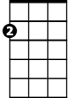

Am

F



**C Am F C**

Moon River, wider than a mile

**F C Dm E7**

I'm crossing you in style some day



G

E7

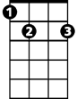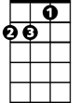

Dm

**Am Em F Em**

Oh, dream maker, you heart breaker

**Am D Em F G**

Wherever you're goin', I'm goin' your way

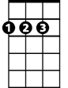

D

Em

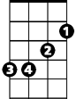

**C Am F C**

Two drifters, off to see the world

**F C Dm E7**

There's such a lot of world to see

**Am Em Am F C**

We're af - ter the same rainbow's end,

**F C F C**

Waitin' 'round the bend, my Huckleberry friend,

**Am F G C**

Moon River, and me

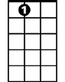

E7



Em



D

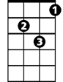

Dm



F



G



Am

C



**BARITONE**

**C Am F G**

**(Repeat entire song)**

**C Am (3X) End C**

Moon River

**Moon River (Johnny Mercer / Henry Mancini) Key G**

**Intro: G Em C D**



G

Em



C

**G Em C G**

Moon River, wider than a mile

**C G Am B7**



Am



D

I'm crossing you in style some day

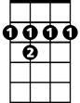

B7

**Em Bm C Bm**

Oh, dream maker, you heart breaker

**Em A Bm C D**

Wherever you're goin', I'm goin' your way

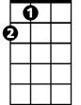

A

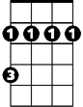

Bm

**G Em C G**

Two drifters, off to see the world

**C G Am B7**

There's such a lot of world to see

**Em Bm Em C G**

We're af - ter the same rainbow's end,

**C G C G**

Waitin' 'round the bend, my Huckleberry friend,

**Em C D G**

Moon River, and me

**G Em C D**

**BARITONE**



A

Bm



B7



Am



G



Em

C



D

**(Repeat entire song)**

**G Em (3X) End G**

Moon River

**Moon River (Johnny Mercer / Henry Mancini) Key F**

**Intro: F Dm Bb C**



Bb



Dm

F



**F Dm Bb F**

Moon River, wider than a mile

**Bb F Gm A7**

I'm crossing you in style some day



A7



Gm



C

**Dm Am Bb Am**

Oh, dream maker, you heart breaker

**Dm G Am Bb C**

Wherever you're goin', I'm goin' your way



G



Am

**F Dm Bb F**

Two drifters, off to see the world

**Bb F Gm A7**

There's such a lot of world to see

**Dm Am Dm Bb F**

We're af - ter the same rainbow's end,

**Bb F Bb F**

Waitin' 'round the bend, my Huckleberry friend,

**Dm Bb C F**

Moon River, and me

**F Dm Bb C**

**BARITONE**

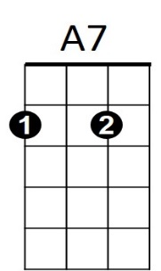



G



Am

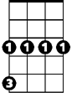

Gm

C

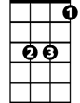

Bb



Dm



F

**(Repeat entire song)**

**F Dm (3X) And F**

Moon River