Moondance (Van Morrison) Key Am

INTRO: Am Bm7 Am Bm7 (two times)  Am Bm7 Am Bm7 Am Bm7 Am Bm7  Well it's a marvelous night for a moondance with the stars up above in your eyes  Am Bm7 Am Bm7 Am Bm7 Am Bm7  A fantabulous night to make romance 'neath the color of October skies  Am Bm7 Am Bm7 Am Bm7 Am Bm7  All th e leaves on the trees are falling to the sounds of the breezes that blow  Am Bm7 Am Bm7 Am Bm7 Am  And I'm trying to place to the calling of your heartstrings that play soft and low  Dm Am Dm Am  You know the ni-ght's magic seems to - whisper and hush  Dm Am Dm E7  You know the so-ft moonlight seems to shine in your blush  Chorus  Am Dm Am Dm Am Dm Am Dm  Can I just have one more moondance with you........my love  Am Dm Am Dm Am Dm Am E7  Can I just have one more moondance with you........my love  Am Bm7 Am Bm7 Am Bm7 Am Bm7  Well I want to make love to you tonight - I can't wait til the morning has come  Am Bm7 Am Bm7 Am Bm7 Am Bm7  And I know now the time is just right - And straight into my arms you will run  Am Bm7 Am Bm7 Am Bm7 Am Bm7  When you come my heart will be waiting - to make sure that you're never alone  Am Bm7 Am Bm7 Am Bm7 Am  There and then all my dreams will come true dear there and then I will make you my own  Dm Am Dm Am  And everytime I - I touch you, you just, tremble inside  Dm Am Dm E7  Then I know ho--w much you want me, that you -- can't hide  (Chorus)  (Repeat Verse 1 Thru Chorus)  Am Dm Am Dm Am Dm Am Dm  One more moondance with you In the moonlight  Am Dm Am Dm Am Dm Am Dm  On a magic night La la la la la la la la la la la la la la la  Am Dm Am Dm Am Dm Am Dm  In the moonlight On a magic night  Am G7 F7 E7 Dm Am  Can I... just have... one more... moondance with you ..My love |  |  |  |  |  |  |  | 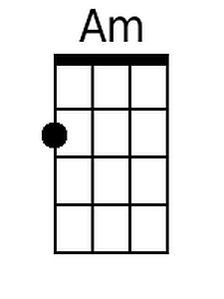
 |  |  |  |  |  |  |  | 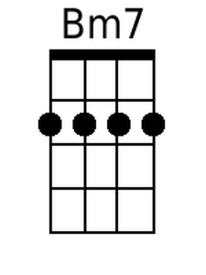
 |  |  |  |  |  |  |  | 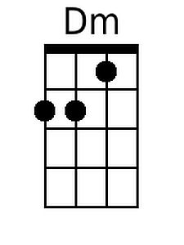
 |  |  |  |  |  |  |  | 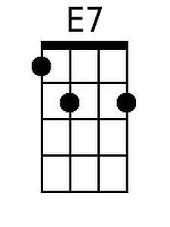
 |  |  |  |  |  |  |  | 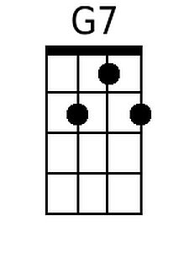
 |  |  |  |  |  |  |  | 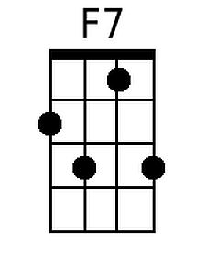
Bari
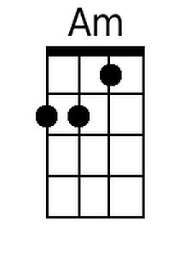 | 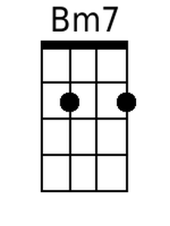 | 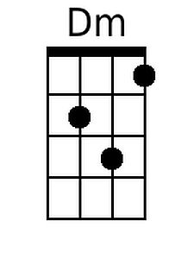 | 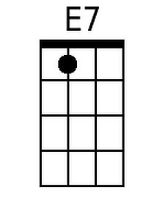 | 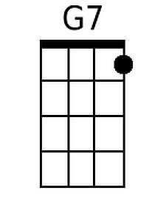 | 