**Moondance (Van Morrison)**

**INTRO: Dm Em7 Dm Em7 (two times)**

**Dm Em7 Dm Em7 Dm Em7 Dm Em7**

Well it's a marvelous night for a moondance with the stars up above in your eyes

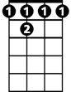

Bb7

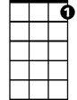

C7

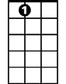

A7

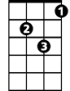

Gm

Em7

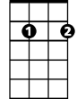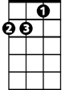

Dm

**Dm Em7 Dm Em7 Dm Em7 Dm Em7**

A fantabulous night to make romance 'neath the color of October skies

**Dm Em7 Dm Em7 Dm Em7 Dm Em7**

All th e leaves on the trees are falling to the sounds of the breezes that blow

**Dm Em7 Dm Em7 Dm Em7 Dm**

And I’m trying to place to the calling of your heartstrings that play soft and low

**Gm Dm Gm Dm**

You know the ni-ght's magic seems to - whisper and hush

**Gm Dm Gm A7**

You know the so-ft moonlight seems to shine in your blush

**CHORUS:**

**Dm Gm Dm Gm Dm Gm Dm Gm**

Can I just have one more moondance with you........my love

**Dm Gm Dm Gm Dm Gm Dm A7**

Can I just have one more moondance with you........my love

**Dm Em7 Dm Em7 Dm Em7 Dm Em7**

Well I want to make love to you tonight - I can't wait til the morning has come

**Dm Em7 Dm Em7 Dm Em7 Dm Em7**

And I know now the time is just right - And straight into my arms you will run

**Dm Em7 Dm Em7 Dm Em7 Dm Em7**

When you come my heart will be waiting - to make sure that you're never alone

**Dm Em7 Dm Em7 Dm Em7 Dm**

There and then all my dreams will come true dear there and then I will make you my own

**Gm Dm Gm Dm**

**BARITONE**

And everytime I – I touch you, you just, tremble inside

**Gm Dm Gm A7**

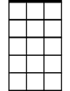

Em7



Dm

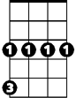

Gm

Then I know ho--w much you want me, that you -- can't hide

**(CHORUS)**

**(REPEAT VERSE 1 THRU CHORUS)**

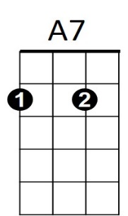 **Dm Gm Dm Gm Dm Gm Dm Gm**

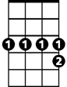

Bb7

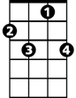

C7

One more moondance with you In the moonlight

**Dm Gm Dm Gm Dm Gm Dm Gm**

On a magic night La la la la la la la la la la la la la la la

**Dm Gm Dm Gm Dm Gm Dm Gm**

In the moonlight On a magic night

**Dm C7 Bb7 A7 Gm Dm**

Can I... just have... one more... moondance with you …..My love