Moonlight Feels Right (Bruce Blackman) Key Am

Am7  The wind blew some luck in my direction  Dm Fmaj7  I caught it in my hands today  Am7  I finally made a tricky French connection  Dm Fmaj7  You winked and gave me your O.K.  D  I'll take you on a trip beside the ocean  Fmaj7  And drop the top at Chesapeake Bay  D  Ain't nothing like the sky to dose a potion  Bb C7  The moon'll send you on your way  Chorus:  Fmaj7 C7  Moonlight - feels right  Fmaj7 C7  Moonlight - feels right  Am7  We'll lay back and observe the constellations  Dm Fmaj7  And watch the moon smilin' bright  Am7  I'll play the radio on southern stations  Dm Fmaj7  'Cause southern belles are hell at night  D  You say you came to Baltimore from Ole Miss  Fmaj7  A Class of seven-four, gold ring  D  The eastern moon looks ready for a wet kiss  Bb C7  To make the tide rise again  (Chorus) | Am7  We'll see the sun come up on Sunday morning  Dm Fmaj7  And watch it fade the moon away  Am7  I guess you know I'm giving you a warning  Dm Fmaj7  'Cause me and moon are itching to play  D  I'll take you on a trip beside the ocean  Fmaj7  And drop the top at Chesapeake Bay  D  Ain't nothin' like the sky to dose a potion  Bb C7  The moon'll send you on your way  (Chorus) (2x)
 |  | 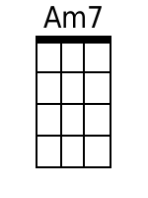 | 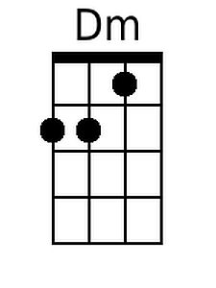 | 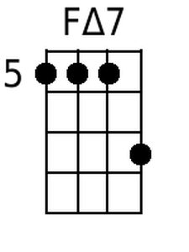
 |  | 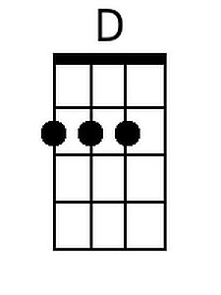 | 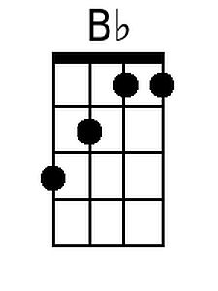 | 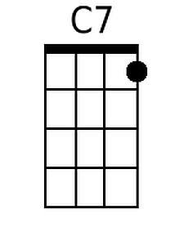
 |  | Bari
 |  | 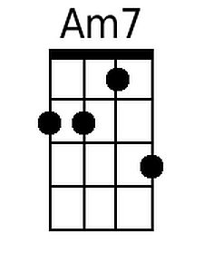 | 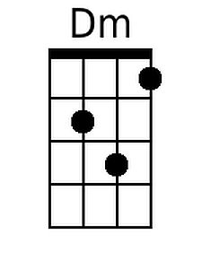 | 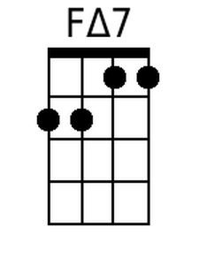
 |  | 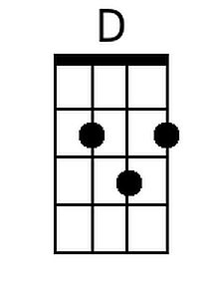 | 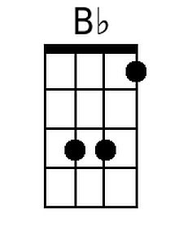 | 