**Moonlight Feels Right (Bruce Blackman)**

**Em7**

The wind blew some luck in my direction

**Am Cmaj7**

I caught it in my hands today

**Em7**

I finally made a tricky French connection

**Am Cmaj7**

You winked and gave me your O.K.

**A**

I'll take you on a trip beside the ocean

**Cmaj7**

And drop the top at Chesapeake Bay

**A**

Ain't nothing like the sky to dose a potion

**F G7**

The moon’ll send you on your way

**Chorus:**

**Cmaj7 G7**

Moonlight - feels right

**Cmaj7 G7**

Moonlight - feels right

**Em7**

We'll lay back and observe the constellations

**Am Cmaj7**

And watch the moon smilin' bright

**Em7**

I'll play the radio on southern stations

**Am Cmaj7**

'Cause southern belles are hell at night

**A**

You say you came to Baltimore from Ole Miss

**Cmaj7**

A Class of seven-four, gold ring

**A**

The eastern moon looks ready for a wet kiss

**F G7**

To make the tide rise again

**(Chorus)**

**Em7**

We'll see the sun come up on Sunday morning

**Am Cmaj7**

And watch it fade the moon away

**Em7**

I guess you know I'm giving you a warning

**Am Cmaj7**

'Cause me and moon are itching to play

**A**

I'll take you on a trip beside the ocean

**Cmaj7**

And drop the top at Chesapeake Bay

**A**

Ain't nothin' like the sky to dose a potion

**F G7**

The moon'll send you on your way

**(Chorus) (2x)**

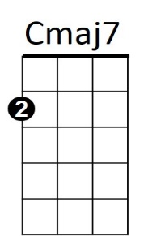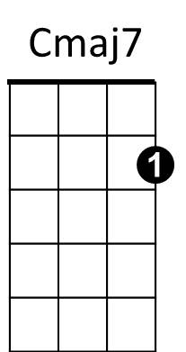

**BARITONE**



F

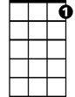

G7

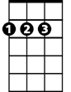

A

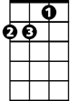

Am

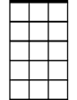

Em7

F

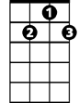

G7

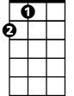

A

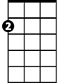

Am

Em7

