Moonshadow (Cat Stevens) Key G

Intro: G C G C G  Chorus:  G C G  Oh, I'm bein' followed by a moon-shadow,  C G  Moonshadow, moonshadow  G C G  Leapin and hoppin' on a moon-shadow,  C G  Moonshadow, moonshadow  C G C G  And if I ever lose my hands,  C G C D  Lose my plough, lose my land,  C G C G  Oh if I ever lose my hands,  Am D7 G Em  Oh i-i-i-i-i-i-i-i-if.....................  Am D7 G  I won't have to work no more.  C G C G  And if I ever lose my eyes,  C G C D  If my colors all run dry,  C G C G  Yes if I ever lose my eyes,  Am D7 G Em  Oh i-i-i-i-i-i-i-i-if.....................  Am D7 G  I won't have to cry no more. Chorus  C G C G  And if I ever lose my legs,  C G C D  I won't moan, and I won't beg,  C G C G  Yes if I ever lose my legs,  Am D7 G Em  Oh i-i-i-i-i-i-i-i-if.....................  Am D7 G  I won't have to walk no more. | C G C G  And if I ever lose my mouth,  C G C D  All my teeth, north and south,  C G C G  Yes if I ever lose my mouth,  Am D7 G Em  Oh i-i-i-i-i-i-i-i-if.....................  Am D7 G  I won't have to talk… Chorus  Reprise:  A D  Did it take long to find me?  A D  I asked the faithful light.  A D  Did it take long to find me?  A D D7  And are you gonna stay the night?  (Chorus)  F C 2X  Moonshadow, moonshadow |  |  |  | 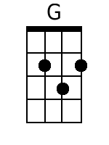  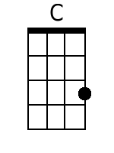  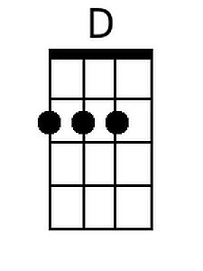  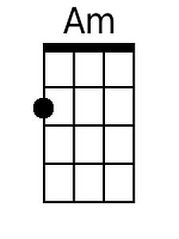  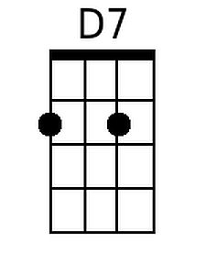  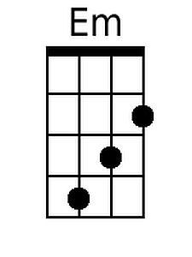  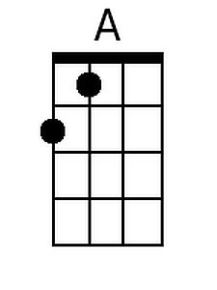
 | Bari
 | 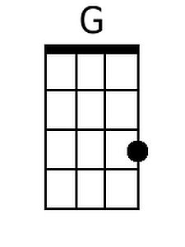 | 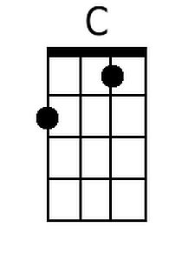 | 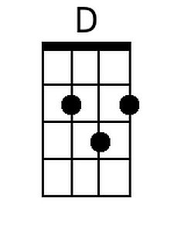 | 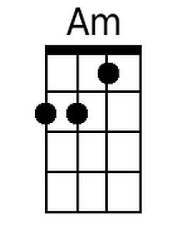
 | 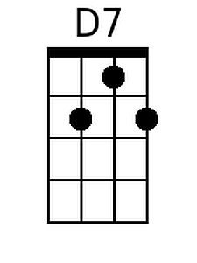 | 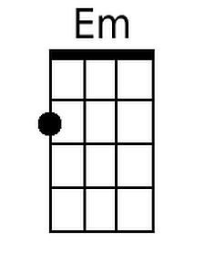 | 