**Moonshadow (Cat Stevens)**

**Intro: C F C F C**

**Chorus:**

**C F C**

Oh, I'm bein' followed by a moon-shadow,

**F C**

Moonshadow, moonshadow

**C F C**

Leapin and hoppin' on a moon-shadow,

**F C**

Moonshadow, moonshadow

**F C F C**

And if I ever lose my hands,

**F C F G**

Lose my plough, lose my land,

**F C F C**

Oh if I ever lose my hands,

**Dm G7 C Am**

Oh i-i-i-i-i-i-i-i-if.....................

**Dm G7 C**

I won't have to work no more.

**F C F C**

And if I ever lose my eyes,

**F C F G**

If my colors all run dry,

**F C F C**

Yes if I ever lose my eyes,

**Dm G7 C Am**

Oh i-i-i-i-i-i-i-i-if.....................

**Dm G7 C**

I won't have to cry no more.

**(Chorus)**

**F C F C**

And if I ever lose my legs,

**F C F G**

I won't moan, and I won't beg,

**F C F C**

Yes if I ever lose my legs,

**Dm G7 C Am**

Oh i-i-i-i-i-i-i-i-if.....................

**Dm G7 C**

I won't have to walk no more.

**F C F C**

And if I ever lose my mouth,

**F C F G**

All my teeth, north and south,

**F C F C**

Yes if I ever lose my mouth,

**Dm G7 C Am**

Oh i-i-i-i-i-i-i-i-if.....................

**Dm G7 C**

I won't have to talk...

**(Chorus)**

**Reprise:**

**D G**

Did it take long to find me?

**D G**

I asked the faithful light.

**D G**

Did it take long to find me?

**D G G7**

And are you gonna stay the night?

**(Chorus)**

**F C 2X**

Moonshadow, moonshadow

**BARITONE**



C

F



G

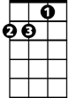

Dm

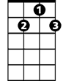

G7

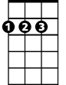

D

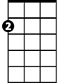

Am

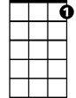

G7



Am



D



G



F



C

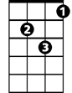

Dm