**More (Riz Ortolani & Nino Oliviero)** **Key of C**

**(Theme from *Mondo Cane*)**

**C**

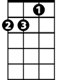

Dm

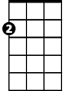

Am



C

**C Am Dm G7**

More than the greatest love the world has known

**C Am Dm G7**

This is the love I'll give to you alone

**C Am Dm G7**

More than the simple words I try to say

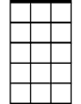

Am7

E7

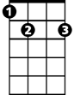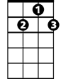

G7

**C Am Dm G7**

I only live to love you more each day

**Am Dm**

More than you'll ever know

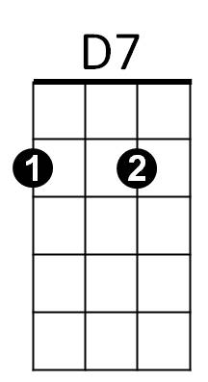 **Am Dm**

F



My arms long to hold you so

**C Dm**

My life will be in your keeping

**C G7**

Wak ing, sleeping, laughing, weeping

**C Am Dm G7**

Longer than alw ays is a long, long time

**C Am Dm E7**

**BARITONE**

But far beyond forever you'll be mine

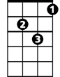

Dm



Am

C



**Am Am7 Am**

I know I've never lived before

**D7 Dm**

And my heart is very sure

**G7 C**

No one else could love you more

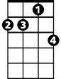

Am7

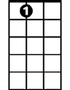

E7

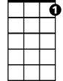

G7

**C Am Dm G7**

Longer than always is a long, long time

**C Am Dm E7**

But far beyond forever you'll be mine

**Am Am7 Am**



D7



F

I know I've never lived before

**D7 Dm**

And my heart is very sure

**G7 C F C**

No one else could love you more

**More (Riz Ortolani & Nino Oliviero)** **Key of G**

**(Theme from *Mondo Cane*)**

**G**



Am

Em

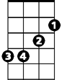

G

**G Em Am D7**

**BARITONE**

More than the greatest love the world has known

**G Em Am D7**

This is the love I'll give to you alone

**G Em Am D7**

****More than the simple words I try to say

Em7

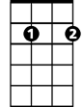

**G Em Am D7**

I only live to love you more each day

**Em Am**

More than you'll ever know

**Em Am**



A7



C

My arms long to hold you so

**C Am**

My life will be in your keeping

**C D7**

Waking, sleeping, laughing, weeping

**G Em Am D7**

Longer than always is a long, long time

**G Em Am B7**

But far beyond forever you'll be mine

**Em Em7 Em**



G



Am



Em

I know I've never lived before

**A7 Am**

And my heart is very sure

**D7 G**

No one else could love you more



Em7

B7



D7



Em

**G Em Am D7**

Longer than always is a long, long time

**G Em Am B7**

But far beyond forever you'll be mine

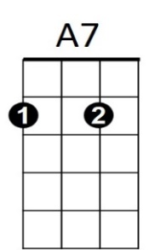**Em Em7 Em**

C



I know I've never lived before

**A7 Am**

And my heart is very sure

**D7 G C G**

No one else could love you more