Morningtown Ride
Malvina Reynolds (1957)
The Seekers, Morningtown Ride (1966)

Introduction: C G Em D7 G D (Last line of chorus)  G G7 C G  1. Train whistle blowin', makes a sleepy noise  C G Am D7  Underneath their blankets go all the girls and boys.  Chorus  G G7 C G  Rockin', Rollin', Ridin', out along the bay  C G Em D7 G - D  All bound for Morning-town, many miles a-way.  Last time through:  C G Em D7 G  All bound for Morning-town, many miles a-way.  G G7 C G  2. Driver at the engine, Fireman rings the bell  C G Am D7  Sandman swings the lantern to show that all is well. Chorus.  G G7 C G  3. Maybe it is raining where our train will ride  C G Am D7  All the little trave'lers are warm and snug in-side. Chorus.  G G7 C G  4. Somewhere there is sunshine, somewhere there is day  C G Am D7  Somewhere there is Morningtown, many miles a-way. Chorus. |  |  |  |  | 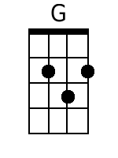  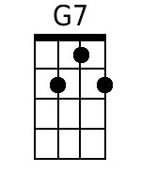  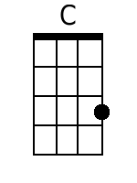 | 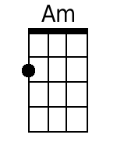  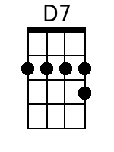  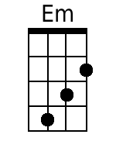  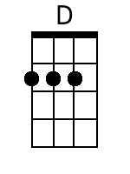
Bari
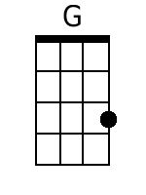 | 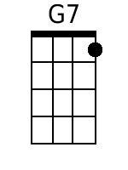 | 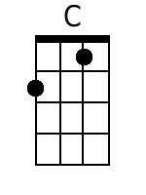 | 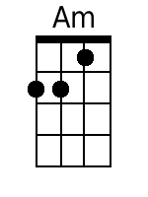 | 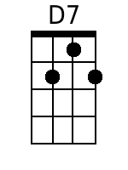 | 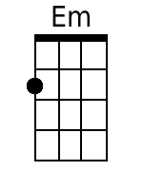 | 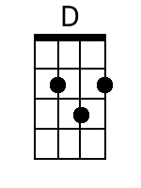

Morningtown Ride
Malvina Reynolds (1957)
The Seekers, Morningtown Ride (1966)

Introduction: F C Am G7 C G (last line of chorus)  C C7 F C  1. Train whistle blowin', makes a sleepy noise  F C Dm G7  Underneath their blankets go all the girls and boys.  Chorus.  C C7 F C  Rockin', Rollin', Ridin', out along the bay  F C Am G7 C G  All bound for Morning-town, many miles a-way.  Last time through:  F C Am G7 C  All bound for Morning-town, many miles a-way.  C C7 F C  2. Driver at the engine, Fireman rings the bell  F C Dm G7  Sandman swings the lantern to show that all is well. Chorus.  C C7 F C  3. Maybe it is raining where our train will ride  F C Dm G7  All the little trave'lers are warm and snug in-side. Chorus.  C C7 F C  4. Somewhere there is sunshine, somewhere there is day  F C Dm G7  Somewhere there is Morningtown, many miles a-way. Chorus. |  |  |  |  | 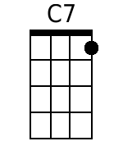  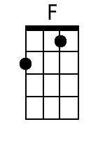 | 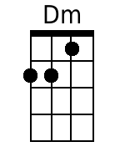
Bari
 | 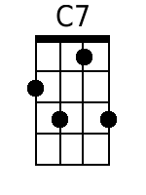 | 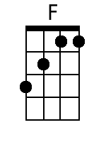 | 