Mr Tambourine Man (Bob Dylan)
Key of G – 4/4 Time - The Byrds, https://www.youtube.com/watch?v=NyOzGPbn2tg

INTRO:  |D Dsus4 Dsus2 D| x2  CHORUS 1:  G A D G  Hey! Mr. Tambourine Man, play a song for me,  D G A Asus4 Asus2 A  I'm not sleepy and there ain't no place I'm goin' to.  G A D G  Hey! Mr. Tambourine Man, play a song for me,  D G A D Dsus4 Dsus2 D  In the jingle jangle morning, I'll come followin' you.  VERSE 1:  G A D G  Take me for a trip upon your magic swirlin' ship,  D G  All my senses have been stripped,  D G  And my hands can't feel to grip.  D G  And my toes too numb to step,  D G A  Wait only for my boot heels, to be wanderin'.  VERSE 2:  G A D G  I'm ready to go anywhere, I'm ready for to fade,  D G  On to my own parade.  D G  Cast your dancin' spell my way,  A  I promise to go under it. |  |  |  |  |  |  | 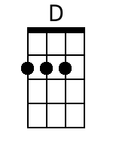
 |  |  |  |  |  |  | 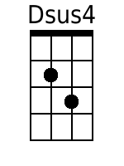
 |  |  |  |  |  |  | 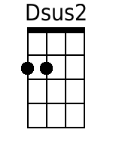
 |  |  |  |  |  |  | 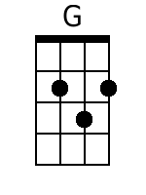
 |  |  |  |  |  |  | 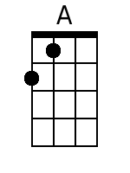
 |  |  |  |  |  |  | 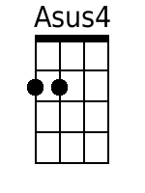
 |  |  |  |  |  |  | 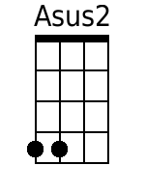
 |  |  |  |  |  |  | 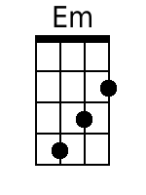
Bari
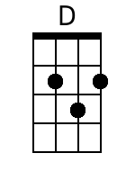 | 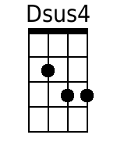 | 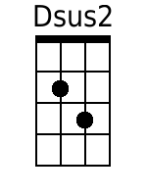 | 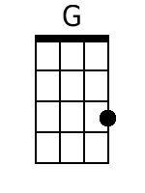 | 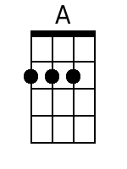 | 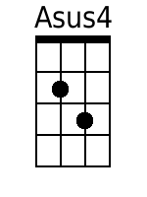 | 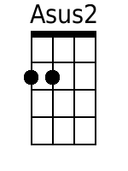 | 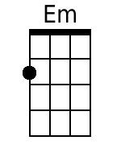

CHORUS 2:
A D G
Hey! Mr. Tambourine Man, play a song for me,
D G A Asus4 Asus2 A
I'm not sleepy and there ain't no place I'm goin' to.
G A D G
Hey! Mr. Tambourine Man, play a song for me,
D G A D Dsus4 Dsus2 D
In the jingle jangle morning, I'll come followin' you.

CHORUS 3 & CODA:
A D G
Hey! Mr. Tambourine Man, play a song for me,
D G A Asus4 Asus2 A
I'm not sleepy and there ain't no place I'm goin' to.
G A D G
Hey! Mr. Tambourine Man, play a song for me,
D G A D Dsus4 Dsus2 D
In the jingle jangle morning, I'll come followin' you.

OUTRO - CHORDS:
|D D Dsus2 D| x2 (Fade)

