Mr. Tambourine Man
Wikipedia, https://en.wikipedia.org/wiki/Mr._Tambourine_Man

"Mr. Tambourine Man" is a song written by Bob Dylan, released as the first track of the acoustic side of his March 1965 album “Bringing It All Back Home.” The song's popularity led to Dylan recording it live many times, and it has been included in multiple compilation albums. The Byrd’s recording was their debut single, released April 12, 1965, reaching number 1 on both the Billboard Hot 100 chart and the UK Singles Chart.
Dylan's song has four verses, of which the Byrds only used the second for their recording. Dylan's and the Byrds' versions have appeared on various lists ranking the greatest songs of all time, including an appearance by both on Rolling Stone's list of the 500 best songs ever. Both versions received Grammy Hall of Fame Awards. The song has been performed and recorded by many other artists, including Judy Collins, Melanie, Odetta, and Stevie Wonder among others.
In his book Keys to the Rain: The Definitive Bob Dylan Encyclopedia, Oliver Trager describes "Mr. Tambourine Man" as having a bright, expansive melody, with Bruce Langhorne's electric guitar accompaniment, which provides a countermelody to the vocals, being the only instrumentation besides Dylan's acoustic guitar and harmonica. In A Darker Shade of Pale, author Wilfred Mellers wrote that although the song is in the key of D major, it is harmonized as if it were in a Lydian G major, giving the song a tonal ambiguity that enhances the dreamy quality of the melody.
The Byrds' recording of the song opens with a distinctive, Bach-inspired guitar introduction played by McGuinn and then, like Dylan's version, goes into the song's chorus. Although Dylan's version contains four verses, the Byrds only perform the song's second verse and two repeats of the chorus, followed by a variation on the song's introduction, which then fades out. The Byrds' version is in a different key from Dylan's original. Jim McGuinn's use of a Rickenbacker 12-string guitar provided a distinctive sound throughout the song as well as his memorable introduction and outro.
The single's success initiated the folk rock boom of 1965 and 1966, with a number of American and British acts imitating the band's hybrid of a rock beat, "jangly" guitar playing, and poetic or socially conscious lyrics. The single was the "first folk rock smash hit", and gave rise to the term "folk rock" in the U.S music press to describe the band's sound. The success of the Byrds' debut created a template for folk rock that proved successful for many acts during the mid-1960s.
- Dylan's Lyrics, https://dylanchords.info/05_biabh/mr_tambourine_man.htm
- Dylan's Performance at YouTube, https://www.youtube.com/watch?v=PYF8Y47qZQY

Mr Tambourine Man (Bob Dylan)
Key of G – 4/4 Time - The Byrds, https://www.youtube.com/watch?v=NyOzGPbn2tg

INTRO – CHORDS (8 measures):  | D | Dsus4 | Dsus2 | D | (Repeat)  CHORUS 1:  G A D G  Hey! Mr. Tambourine Man, play a song for me,  D G A Asus4 Asus2 A  I'm not sleepy and there ain't no place I'm goin' to.  G A D G  Hey! Mr. Tambourine Man, play a song for me,  D G A D Dsus4 Dsus2 D  In the jingle jangle morning, I'll come followin' you.  VERSE 1:  G A D G  Take me for a trip upon your magic swirlin' ship,  D G  All my senses have been stripped,  D G  And my hands can't feel to grip.  D G  And my toes too numb to step,  D G A  Wait only for my boot heels, to be wanderin'.  VERSE 2:  G A D G  I'm ready to go anywhere, I'm ready for to fade,  D G  On to my own parade.  D G  Cast your dancin' spell my way,  A  I promise to go under it. |  |  |  |  |  |  | 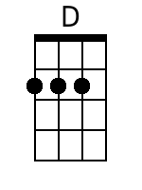
 |  |  |  |  |  |  | 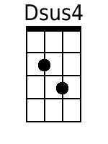
 |  |  |  |  |  |  | 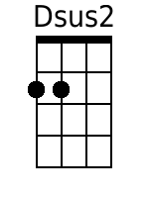
 |  |  |  |  |  |  | 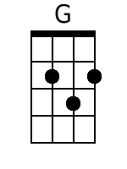
 |  |  |  |  |  |  | 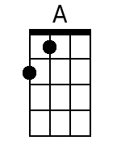
 |  |  |  |  |  |  | 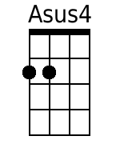
 |  |  |  |  |  |  | 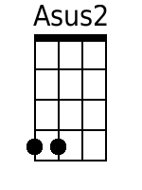
 |  |  |  |  |  |  | 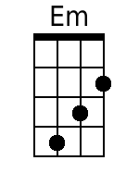
Bari
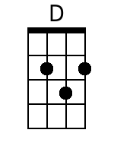 | 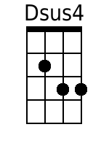 | 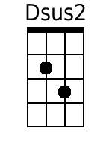 | 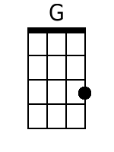 | 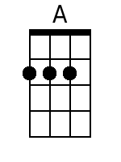 | 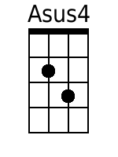 | 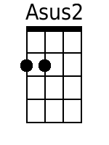 | 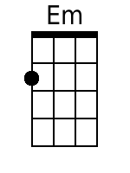

CHORUS 2:
A D G
Hey! Mr. Tambourine Man, play a song for me,
D G A Asus4 Asus2 A
I'm not sleepy and there ain't no place I'm goin' to.
G A D G
Hey! Mr. Tambourine Man, play a song for me,
D G A D Dsus4 Dsus2 D
In the jingle jangle morning, I'll come followin' you.

CHORUS 3 & CODA:
A D G
Hey! Mr. Tambourine Man, play a song for me,
D G A Asus4 Asus2 A
I'm not sleepy and there ain't no place I'm goin' to.
G A D G
Hey! Mr. Tambourine Man, play a song for me,
D G A D Dsus4 Dsus2 D
In the jingle jangle morning, I'll come followin' you.

OUTRO – CHORDS (8 measures):
| D | Dsus4 | Dsus2 | D | (Repeat)

INTRO – RIFF (Baritone): (12-string lead over):
ee|——————————————————————————-
bb|——————————————————————————-
Gg|——-2--4-2-0-2—————————-0-0—
Dd|-0--0——————————2-0-2-2————- x2

INTRO - BASS:
G|——————————————————————————-
D|——————————————————————————-
A|——————————————————————————-
D|———————————-——-0-0/1^7-7———

OUTRO – RIFF (Baritone): (12-string lead over):
ee|——————————————————————————-
bb|——————————————————————————-
Gg|——-2--4-2-0-2—————————-0-0—
Dd|-0--0——————————2-0-2-2————- x2 (Fade)

OUTRO - BASS:
G|——————————————————————————-
D|——————————————————————————-
A|——————————————————————————-
D|—————-0-0/1^7-7-0-0/1^7-7—- x2 (Fade)

Chords (Baritone):

D | 0232
Dsus4 | 0233
Dsus2 | 0230
G | 0033
A | 2220
Asus4 | 2230
Asus2 | 2200
Em | 2000

