Mr Tambourine Man (Bob Dylan, 1964) (C)
Mr. Tambourine Man by The Byrds (1965)

Intro* | C F G G | (4x)  Chorus  F G C F  Hey! Mr. Tambourine Man, play a song for me,  C F G Gsus2 | G Gsus2  I'm not sleepy and there ain't no place I'm goin' to.  F G C F  Hey! Mr. Tambourine Man, play a song for me,  C F G C Csus4 | C Csus4  In the jingle jangle morning, I'll come followin' you.  F G C F  Take me for a trip upon your magic swirlin' ship,  C F C F  All my senses have been stripped, and my hands can't feel to grip.  C F  And my toes too numb to step,  C F G Gsus2 | G Gsus2  Wait only for my boot heels, to be wanderin'.  F G C F  I'm ready to go anywhere, I'm ready for to fade,  C F C F  On to my own parade. Cast your dancin' spell my way,  G Gsus2 | G Gsus2  I promise to go under it. Chorus  F G C F  Hey! Mr. Tambourine Man, play a song for me,  C F G Gsus2 | G Gsus2  I'm not sleepy and there ain't no place I'm goin' to.  F G C F  Hey! Mr. Tambourine Man, play a song for me,  C F G C  In the jingle jangle morning, I'll come followin' you.  Outro | C F G G | (4x) | C (Hold)  A ----------0---------------------------------------  E ----3--------3---1---0--------------------------  C -0----0------------------2—0---3—3---0---3  G --------------------------------------------------- | 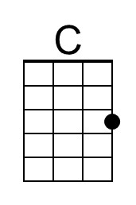 | 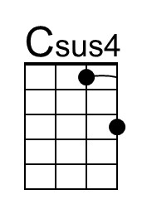
 | 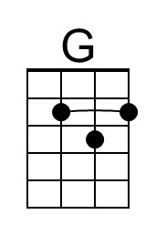 | 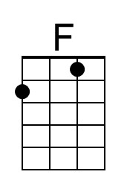
 | 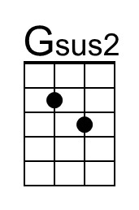
 | Bari
 | 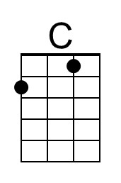 | 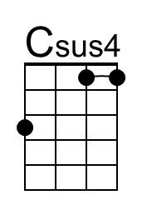
 | 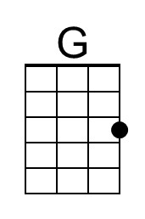 | 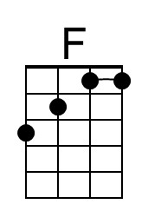
 | 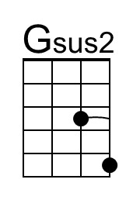

*The strum pattern for the Intro & Outro is: C F G G
DDU - DUDU – DUDU _UDU
Mr Tambourine Man (Bob Dylan, 1964) (D)
Mr. Tambourine Man by The Byrds (1965)

Intro* | D G A A | (4x)  Chorus  G A D G  Hey! Mr. Tambourine Man, play a song for me,  D G A Asus2 | A Asus2  I'm not sleepy and there ain't no place I'm goin' to.  G A D G  Hey! Mr. Tambourine Man, play a song for me,  D G A D Dsus4 | D Dsus4  In the jingle jangle morning, I'll come followin' you.  G A D G  Take me for a trip upon your magic swirlin' ship,  D G D G  All my senses have been stripped, and my hands can't feel to grip.  D G  And my toes too numb to step,  D G A Asus2 | A Asus2  Wait only for my boot heels, to be wanderin'.  G A D G  I'm ready to go anywhere, I'm ready for to fade,  D G D G  On to my own parade. Cast your dancin' spell my way,  A Asus2 | A Asus2  I promise to go under it. Chorus  G A D G  Hey! Mr. Tambourine Man, play a song for me,  D G A Asus2 | A Asus2  I'm not sleepy and there ain't no place I'm goin' to.  G A D G  Hey! Mr. Tambourine Man, play a song for me,  D G A D  In the jingle jangle morning, I'll come followin' you.  Outro | D G A A | (4x) | D (Hold)  A ----0-----2---0---------------------------------  E -------------------3---2---0------0---0-------0  C -2----2-----------------------2—---------2----  G --------------------------------------------------- | 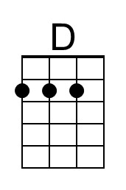 | 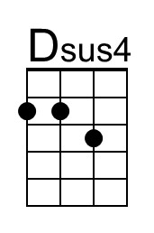
 | 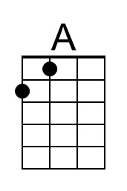
 | 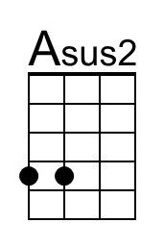
 | Bari
 | 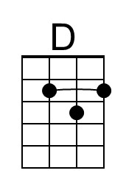 | 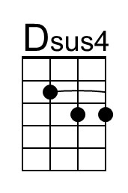
 | 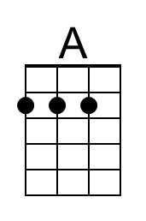
 | 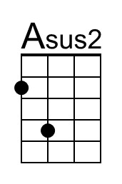

*The strum pattern for the Intro & Outro is: D G A A
DDU - DUDU – DUDU _UDU

Mr Tambourine Man (Bob Dylan, 1964) (G)
Mr. Tambourine Man by The Byrds (1965)

Intro* | G C D D | (4x)  Chorus  C D G C  Hey! Mr. Tambourine Man, play a song for me,  G C D Dsus2 | D Dsus2  I'm not sleepy and there ain't no place I'm goin' to.  C D G C  Hey! Mr. Tambourine Man, play a song for me,  G C D G Gsus4 | G Gsus4  In the jingle jangle morning, I'll come followin' you.  C D G C  Take me for a trip upon your magic swirlin' ship,  G C G C  All my senses have been stripped, And my hands can't feel to grip.  G C  And my toes too numb to step,  G C D Dsus2 | D Dsus2  Wait only for my boot heels, to be wanderin'.  C D G C  I'm ready to go anywhere, I'm ready for to fade,  G C G C  On to my own parade. Cast your dancin' spell my way,  D Dsus2 | D Dsus2  I promise to go under it. Chorus  C D G C  Hey! Mr. Tambourine Man, play a song for me,  G C D Dsus2 | D Dsus2  I'm not sleepy and there ain't no place I'm goin' to.  C D G C  Hey! Mr. Tambourine Man, play a song for me,  G C D G  In the jingle jangle morning, I'll come followin' you.  Outro | G C D D | (4x) | G (Hold)  A -------------------------------------------------------------------  E -------------0----------------------------------------------------  C ------2----------2---0------------------------------------------  G --0------0---------------4-----2----0----2----2----0----2--- |  | 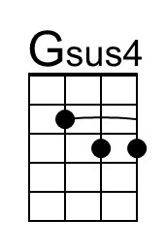
 | 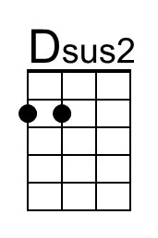
 | Bari
 |  | 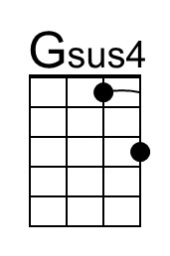
 | 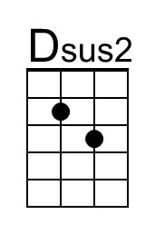

*The strum pattern for the Intro & Outro is: G C D D
DDU - DUDU – DUDU _UDU

