Mr Tambourine Man (Bob Dylan, 1964) (D)
Mr. Tambourine Man by The Byrds (1965) (D)
4/4 Time – Tempo = 120 bpm

[ Hum Tune, if helpful ] Strum pattern: D G A A
Intro* | D G A A | (4x) DDU - DUDU – DUDU _UDU

Chorus
G A D G
Hey! Mr. Tambourine Man, play a song for me,
D G A Asus2 | A Asus2
I'm not sleepy and there ain't no place I'm goin' to.
G A D G
Hey! Mr. Tambourine Man, play a song for me,
D G A D Dsus4 | D Dsus4
In the jingle jangle morning, I'll come followin' you.

G A D G
Take me for a trip upon your magic swirlin' ship,
D G D G
All my senses have been stripped, and my hands can't feel to grip.
D G
And my toes too numb to step,
D G A Asus2 | A Asus2
Wait only for my boot heels, to be wanderin'.

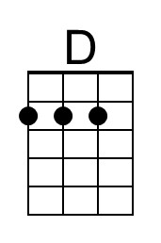 | 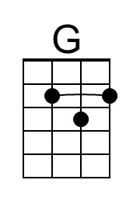 | 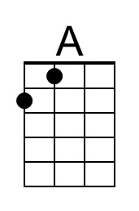 |  | Bari | 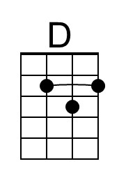 | 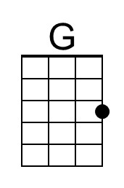 | 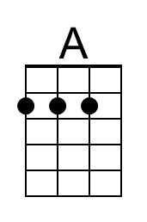
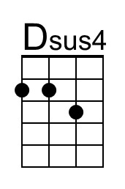 |  | 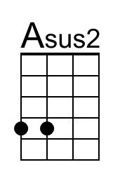 |  |  | 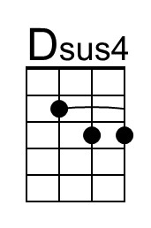 |  | 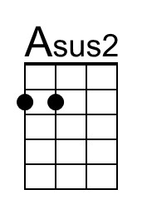

Mr. Tambourine Man (D) – Page 2

G A D G
I'm ready to go anywhere, I'm ready for to fade,
D G D G
On to my own parade. Cast your dancin' spell my way,
A Asus2 | A Asus2
I promise to go under it.

Chorus
G A D G
Hey! Mr. Tambourine Man, play a song for me,
D G A Asus2 | A Asus2
I'm not sleepy and there ain't no place I'm goin' to.
G A D G
Hey! Mr. Tambourine Man, play a song for me,
D G A D
In the jingle jangle morning, I'll come followin' you.

Outro | D G A A | (4x) | D (Hold)

