Mr. Tambourine Man (Bob Dylan, 1964) (C)
Mr. Tambourine Man by The Byrds (1965) (D)
4/4 Time – Tempo 120 bpm

[ Hum Tune, if helpful ] Pattern: C F G G
Intro | C F G G | (4x) DUD_ DUDU DUDU _UDU

Chorus
F G C F
Hey! Mr. Tambourine Man, play a song for me,
C F G Gsus2 | G Gsus2
I'm not sleepy and there ain't no place I'm goin' to.
F G C F
Hey! Mr. Tambourine Man, play a song for me,
C F G C Csus4 | C Csus4
In the jingle jangle morning, I'll come followin' you.

F G C F
Take me for a trip upon your magic swirlin' ship,
C F C F
All my senses have been stripped, and my hands can't feel to grip.
C F
And my toes too numb to step,
C F G Gsus2 | G Gsus2
Wait only for my boot heels, to be wanderin'.

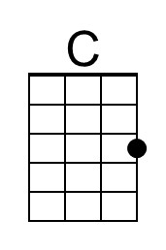 | 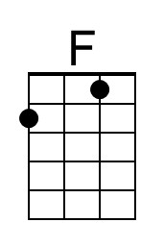 | 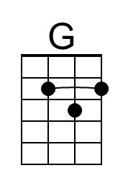 |  | Bari | 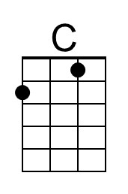 | 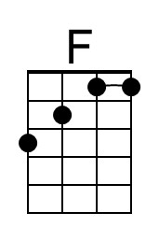 | 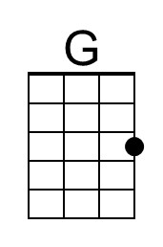
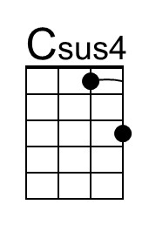 |  | 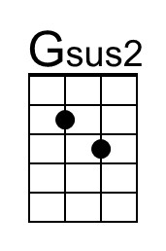 |  |  | 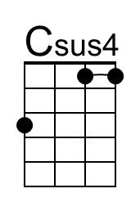 |  | 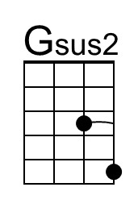

Mr. Tambourine Man (C) – Page 2

F G C F
I'm ready to go anywhere, I'm ready for to fade,
C F C F
On to my own parade. Cast your dancin' spell my way,
G Gsus2 | G Gsus2
I promise to go under it.

Chorus
F G C F
Hey! Mr. Tambourine Man, play a song for me,
C F G Gsus2 | G Gsus2
I'm not sleepy and there ain't no place I'm goin' to.
F G C F
Hey! Mr. Tambourine Man, play a song for me,
C F G C
In the jingle jangle morning, I'll come followin' you.

Outro | C F G G | (4x) | C (Hold)

C F G G
(Pattern: DUD_ DUDU DUDU _UDU)

C-Tuning Intro (2x)
C G C A G F E | D C F D D C C D (2x)
A ----------0----------|------------------------|-
E ----3--------3--1--0-|-------1----------------|-
C -0-----0-------------|-2--0-----2--2--0--0--2-|-
G ---------------------|------------------------|-

G-Tuning Intro (2x)
C G C A G F E | D C F D D C C D (2x)
E ----3-----5--3--1--0-|-------1----------------|-
B -2-----2-------------|-3--1-----3--3--1--1--3-|-
G ---------------------|------------------------|-
D ---------------------|------------------------|-

Mr Tambourine Man (Bob Dylan, 1964) (D)
Mr. Tambourine Man by The Byrds (1965) (D)
4/4 Time – Tempo = 120 bpm

[ Hum Tune, if helpful ] Pattern: D G A A
Intro | D G A A | (4x) DUD_ DUDU DUDU _UDU

Chorus
G A D G
Hey! Mr. Tambourine Man, play a song for me,
D G A Asus2 | A Asus2 |
I'm not sleepy and there ain't no place I'm goin' to.
G A D G
Hey! Mr. Tambourine Man, play a song for me,
D G A D Dsus4 | D Dsus4 |
In the jingle jangle morning, I'll come followin' you.

G A D G
Take me for a trip upon your magic swirlin' ship,
D G
All my senses have been stripped,
D G
And my hands can't feel to grip,
D G
And my toes too numb to step,
D G A Asus2 | A Asus2
Wa - it only for my boot heels to be wanderin'.

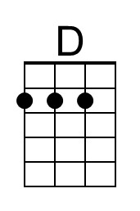 |  | 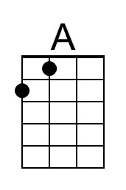 |  | Bari | 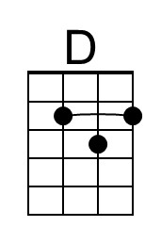 |  | 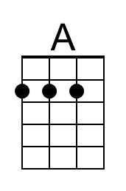
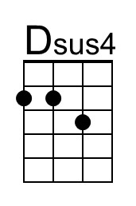 |  | 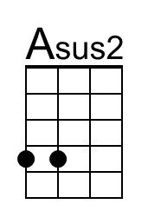 |  |  | 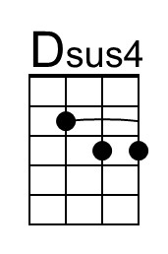 |  | 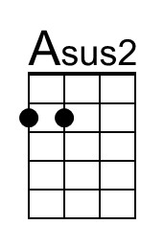

Mr. Tambourine Man (D) – Page 2

G A
I'm ready to go anywhere,
D G
I'm ready for to fade,
D G
On to my own parade,
D G
Cast your dancin' spell my way,
A Asus2 | A Asus2 |
I promise to go under it.

Chorus
G A D G
Hey! Mr. Tambourine Man, play a song for me,
D G A Asus2 | A Asus2 |
I'm not sleepy and there ain't no place I'm goin' to.
G A D G
Hey! Mr. Tambourine Man, play a song for me,
D G A D . . . |
In the jingle jangle morning, I'll come followin' you.

[ Hum Tune, if helpful ] Pattern: D G A A
Outro | D G A A | (4x) DUD_ DUDU DUDU _UDU

Mr. Tambourine Man (Bob Dylan, 1964) (G)
Mr. Tambourine Man by The Byrds (1965) (D)
4/4 Time – Tempo = 120 bpm

[ Hum Tune, if helpful ] Pattern: G C D D
Intro | G C D D | (4x) DUD_ DUDU DUDU _UDU

Chorus
C D G C
Hey! Mr. Tambourine Man, play a song for me,
G C D Dsus2 | D Dsus2 |
I'm not sleepy and there ain't no place I'm goin' to.
C D G C
Hey! Mr. Tambourine Man, play a song for me,
G C D G Gsus4 | G Gsus4 |
In the jingle jangle morning, I'll come followin' you.

C D G C
Take me for a trip upon your magic swirlin' ship,
G C
All my senses have been stripped,
G C
And my hands can't feel to grip,
G C
And my toes too numb to step,
G C
Wa - it only for my boot
D Dsus2 | D Dsus2
heels to be wanderin'.

 |  |  |  | Bari
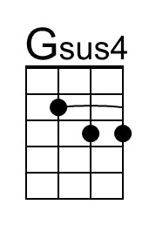 |  | 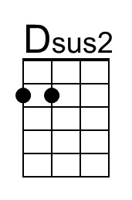 |  |  | 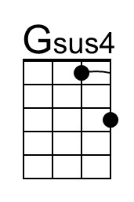 |  | 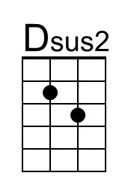

Mr. Tambourine Man (G) – Page 2

C D
I'm ready to go anywhere,
G C
I'm ready for to fade,
G C
On to my own parade,
G C
Cast your dancin' spell my way,
D Dsus2 | D Dsus2 |
I promise to go under it.

Chorus
C D G C
Hey! Mr. Tambourine Man, play a song for me,
G C D Dsus2 | D Dsus2 |
I'm not sleepy and there ain't no place I'm goin' to.
C D G C
Hey! Mr. Tambourine Man, play a song for me,
G C D G . . . |
In the jingle jangle morning, I'll come followin' you.

[ Hum Tune, if helpful ] Pattern: G C D D
Outro | G C D D | (4x) DUD_ DUDU DUDU _UDU

