**Mrs. Robinson (Paul Simon)**

**E7**

De de de de de de de de de de de de de

**A A7**

Do do do do do do do do do

**D G C G Am E7 D**

De de de de de de de de de de de de de

**Chorus:**

**G Em**

And here's to you, Mrs Robinson

**G Em C**

Jesus loves you more than you will know.

**D**

Whoa whoa whoa

**G Em**

God bless you please, Mrs Robinson

**G Em C**

Heaven holds a place for those who pray

**Am E7**

Hey hey hey Hey hey hey

**E7**

We'd like to know a little bit about you for our files

**A A7**

We'd like to help you learn to help yourself

**D7 G**

Look around you all you see are

**C G Am**

Sympa-thetic eyes

**BARITONE**

**E7 D**

Stroll around the grounds until you feel at home

**(Chorus)**

**E7**

Hide it in a hiding place where no one ever goes

**A A7**

Put in your pantry with your cupcakes

**D7 G C Am**

It's a little secret just the Robinson's affair

**E7 D**

Most of all you've got to hide it from the kids

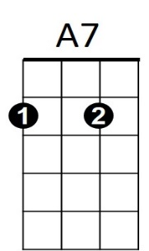



G

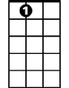

E7

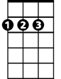

A



D

C



**D G Em**

Koo koo kachoo, Mrs Robinson

**G Em C**

Jesus loves you more than you will know.

**D**

Whoa whoa whoa

**G Em**

God bless you please, Mrs Robinson

**G Em C**

E7

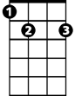

Heaven holds a place for those who pray

**Am E7**

Hey hey hey Hey hey hey

**E7**

Sitting on a sofa on a Sunday afternoon

**A A7**

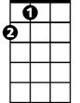

A

Going to the candidates’ debate

**D7 G**

Laugh about it shout about it

**C Am**

When you've got to choose

**E7 D**

Every way you look at it you'll lose



A7

**G Em**

Where have you gone Joe DiMaggio

**G Em C**

A nation turns its lonely eyes to you

**D**

Whoo whoo whoo



D

**G Em**

What's that you say Mrs Robinson

**G Em C**

Joltin' Joe has left and gone away

**Am E7**

Hey hey hey Hey hey hey

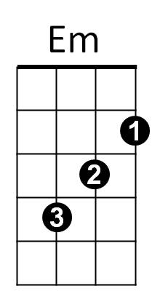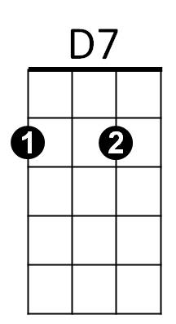

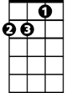

Am

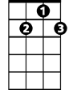

D7

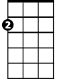

Em



C



Am



G