My Boy Lollipop (Robert Spencer, mid-1950s) (C)
My Boy Lollipop by Millie Small (1964) (D – 143 BPM)

Intro C  C F G C F  My boy Lollipop; you make my heart go giddy up,  G C F G C  You are as sweet as candy; _ you're my sugar dandy.  F G C F G C  _ Oh, oh, my boy Lollipop; _ never, _ ever leave me,  F G C F G C C7  _ Because it would grieve me; _ my heart told me so.  Chorus  F C C7  I love you, I love you, I love you so, that I want you to know.  F G7  I need you, I need you, I need you so and I'll never let you go.  C F G C F  My boy Lollipop; you make my heart go giddy up,  G C F G C  You set my world on fire; _ you are my one de-sire.  F G C  _ Oh, my Lolli-pop...  Instrumental Verse Repeat from Chorus  C, F G (x3), C C7  Outro  F G C F G C  _ Oh, my Lolli-pop, _ Oh, my Lolli-pop.  F G C F G C | G | C  _ Oh, my Lolli-pop, _ Oh, my Lolli-pop. |  |  |  |  |  |  | 
 |  |  |  |  |  |  | 
 |  |  |  |  |  |  | 
 |  |  |  |  |  |  | 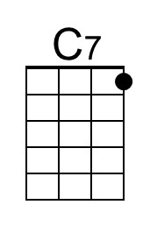
 |  |  |  |  |  |  | 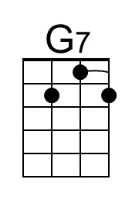
Bari |  |  |  | 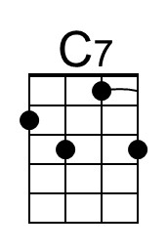 | 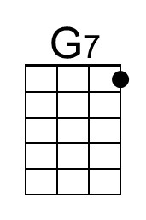

My Boy Lollipop (Robert Spencer, mid-1950s) (D)
My Boy Lollipop by Millie Small (1964) (D – 143 BPM)

Intro D  D G A D G  My boy Lollipop; you make my heart go giddy up,  A D G A D  You are as sweet as candy; _ you're my sugar dandy.  G A D G A D  _ Oh, oh, my boy Lollipop; _ never, _ ever leave me,  G A D G A D D7  _ Because it would grieve me; _ my heart told me so.  Chorus  G D D7  I love you, I love you, I love you so, that I want you to know.  G A7  I need you, I need you, I need you so and I'll never let you go.  D G A D G  My boy Lollipop; you make my heart go giddy up,  A D G A D  You set my world on fire; _ you are my one de-sire.  G A D  _ Oh, my Lolli-pop...  Instrumental Verse Repeat from Chorus  D, G A (x3), D D7  Outro  G A D G A D  _ Oh, my Lolli-pop, _ Oh, my Lolli-pop.  G A D G A D | A | D  _ Oh, my Lolli-pop, _ Oh, my Lolli-pop. |  |  |  |  |  |  | 
 |  |  |  |  |  |  | 
 |  |  |  |  |  |  | 
 |  |  |  |  |  |  | 
Bari |  |  |  |  | 

My Boy Lollipop (Robert Spencer, mid-1950s) (G)
My Boy Lollipop by Millie Small (1964) (D – 143 BPM)

Intro G

G C D G C
My boy Lollipop; you make my heart go giddy up,
D G C D G
You are as sweet as candy; _ you're my sugar dandy.

C D G C D G
_ Oh, oh, my boy Lollipop; _ never, _ ever leave me,
C D G C D G G7
_ Because it would grieve me; _ my heart told me so.

Chorus
C G G7
I love you, I love you, I love you so, that I want you to know.
C D7
I need you, I need you, I need you so and I'll never let you go.

G C D G C
My boy Lollipop; you make my heart go giddy up,
D G C D G
You set my world on fire; _ you are my one de-sire.
C D G
_ Oh, my Lolli-pop...

Instrumental Verse Repeat from Chorus
G, C D (x3), C G7

Outro
C D G C D G
_ Oh, my Lolli-pop, _ Oh, my Lolli-pop.
C D G C D G | D | G
_ Oh, my Lolli-pop, _ Oh, my Lolli-pop.

Bari

