GCEA  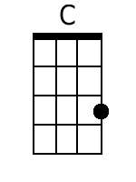  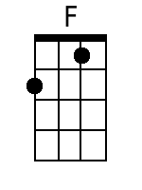  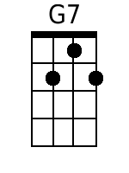  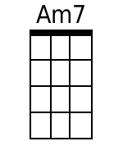  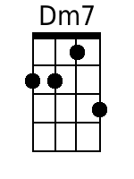  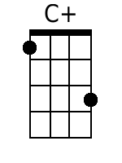  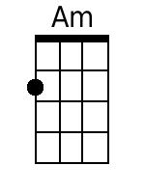  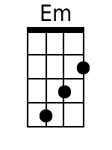 | My Dear Mary Anne  By Randy Sparks and Art Podell  Key of C; 4/4 Time; “Tenderly.” GCEA Ukulele.  Recorded by The New Christy Minstrels on their 1963 album Ramblin'.  Chorus  C F G7 C  Oh, fare thee well, my dear Mary Anne;  Am7 Dm7 G7  Our days have all gone by.  C C+ F G7  Spring is a-comin' and soon I'll be gone;  C Am F Dm7 G7 C ... | Dm7.G7. |  But I'll come back, don-cha cry, my dear Mary Anne.  C F G7 C  1. Oh, don't you see the pretty turtle dove  Dm7 G7  That flies from pine to pine,  C C+ F G7  Cryin' for its own true love,  C Am F Dm7 G7 C ... | Dm7.G7. |  The way I cry for mine, my dear Mary Anne.  C F G7 C  2. A lobster dies in a boiling pot;  Am7 Dm7 G7  Oh, pity, the blue fish, too.  C C+ F G7  Yet they're quickly gone and they suffer not,  C Am F Dm7 G7 C . . . | Dm7 . G . |  Like the ache I bear for you, my dear Mary Anne.  C F G7 C  Oh, fare thee well, my dear Mary Anne;  Am7 Dm7 G7  Our days have all gone by.  C C+ F G7  Spring is a-comin' and soon I'll be gone;  C Am F  But I'll come back, don-cha cry,  Dm7 G7 C . . . |  My dear Mary Anne.  C C+ F G7  Spring is a-comin' and soon I'll be gone;  C Am F  But I'll come back, don-cha cry,  Dm7 G7 C . Em . | Dm . G7 . | C . . . | . .  My dear Mary Anne.

