GCEA  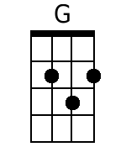  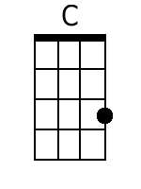  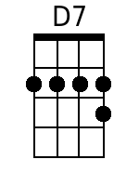  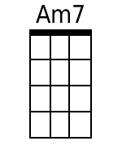  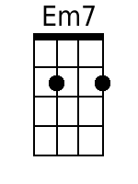  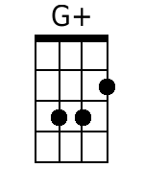  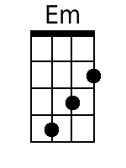  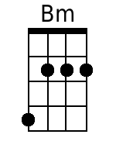 | My Dear Mary Anne  By Randy Sparks and Art Podell  Key of G (Original Key of C); 4/4 Time; “Tenderly.” GCEA Ukulele.  Recorded by The New Christy Minstrels on their 1963 album Ramblin'.  Chorus  G C D7 G  Oh, fare thee well, my dear Mary Anne;  Em7 Am7 D7  Our days have all gone by.  G G+ C D7  Spring is a-comin' and soon I'll be gone;  G Em C  But I'll come back, don-cha cry,  Am7 D7 G ... | Am7.D7. |  my dear Mary Anne.  G C D7 G  1. Oh, don't you see the pretty turtle dove  Am7 D7  That flies from pine to pine,  G G+ C D7  Cryin' for its own true love,  G Em C Am7 D7 G ... | Am7.D7. |  The way I cry for mine, my dear Mary Anne.  G C D7 G  2. A lobster dies in a boiling pot;  Em7 Am7 D7  Oh, pity, the blue fish, too.  G G+ C D7  Yet they're quickly gone and they suffer not,  G Em C Am7 D7 G ... | Am7.D7. |  Like the ache I bear for you, my dear Mary Anne.  G C D7 G  Oh, fare thee well, my dear Mary Anne;  Em7 Am7 D7  Our days have all gone by.  G G+ C D7  Spring is a-comin' and soon I'll be gone;  G Em C Am7 D7 G ...  But I'll come back, don-cha cry, my dear Mary Anne.  G G+ C D7  Spring is a-comin' and soon I'll be gone;  G Em C  But I'll come back, don-cha cry,  Am7 D7 G . Bm . | Am . D7 . | G . . . | . .  My dear Mary Anne.

