My Favorite Things
From the Broadway musical “The Sound of Music” by Richard Rogers and Oscar Hammerstein II (1959); ¾ Time – Key of Am

Intro (4 measures): Am

Am FΔ7
Raindrops on roses and whiskers on kittens, Bright copper kettles and warm woolen mittens
Dm7 G7 C F C F Dm E7 | Am | Am |
Brown paper packages tied up with strings, These are a few of my favorite things

Am FΔ7
Cream colored ponies and crisp apple strudels, Door bells and sleigh bells and schnitzel with noodles
Dm7 G7 C F C F Dm E7 | Am | Am |
Wild geese that fly with the moon on their wings, These are a few of my favorite things

Am D7
Girls in white dresses with blue satin sashes, Snowflakes that stay on my nose and eyelashes
Dm7 G7 C F C F Dm E7
Silver white winters that melt into spring, These are a few of my favorite things

Am Dm E7 Am F
When the dog bites, When the bee stings, When I'm feeling sad
F D7 C F | F | G7 C | F | Dm | E7 | Am | Am |
I simply remember my favorite things, and then I don't feel . . . so bad. Repeat From Top
2nd Time: Outro: G7 C | C | F | F | C | G7 | C

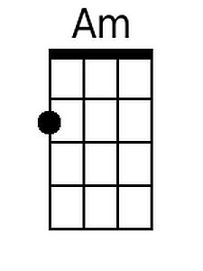 | 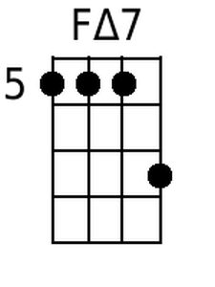 | 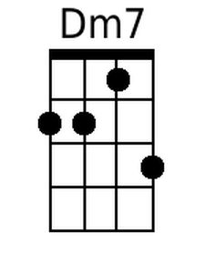 | 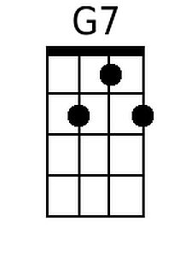 | 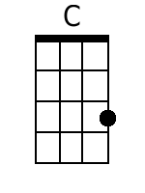 | 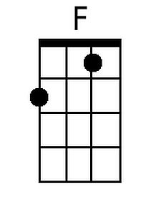 | 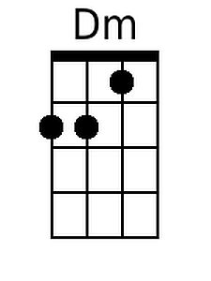 | 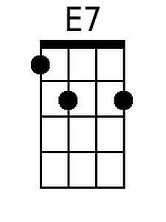 | 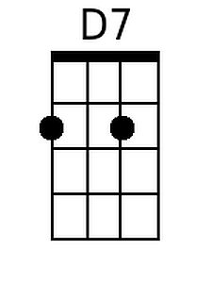
Bari
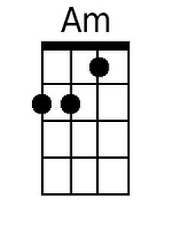 | 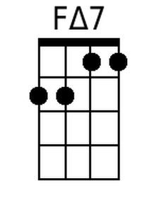 | 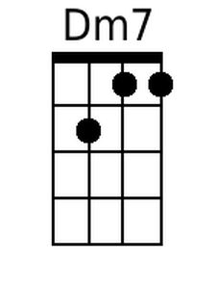 | 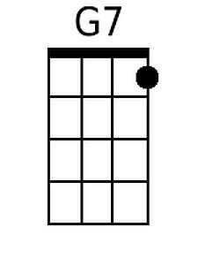 | 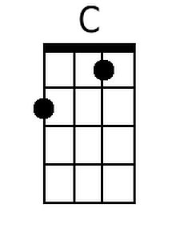 | 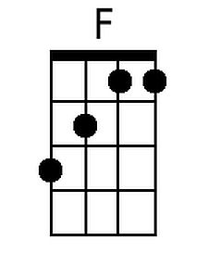 | 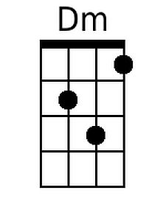 | 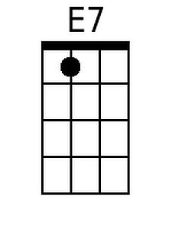 | 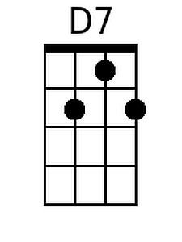

My Favorite Things
From the Broadway musical “The Sound of Music” by Richard Rogers and Oscar Hammerstein II (1959); ¾ Time – Key of Em

Intro (4 measures): Em

Em CΔ7
Raindrops on roses and whiskers on kittens, Bright copper kettles and warm woolen mittens
Am7 D7 G C G C Am B7 | Em | Em |
Brown paper packages tied up with strings, These are a few of my favorite things

Em CΔ7
Cream colored ponies and crisp apple strudels, Door bells and sleigh bells and schnitzel with noodles
Am7 D7 G C G C Am B7 | Em | Em |
Wild geese that fly with the moon on their wings, These are a few of my favorite things

Em A7
Girls in white dresses with blue satin sashes, Snowflakes that stay on my nose and eyelashes
Am7 D7 G C G C Am B7
Silver white winters that melt into spring, These are a few of my favorite things

Em Am B7 Em C
When the dog bites, When the bee stings, When I'm feeling sad
C A7 G C | C | D7 G | C | Am | B7 | Em | Em |
I simply remember my favorite things, and then I don't feel . . . so bad. Repeat From Top
2nd Time: Outro: D7 G | G | C | C | G | D7 | G

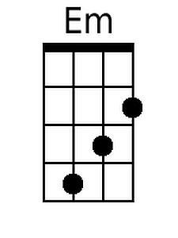 | 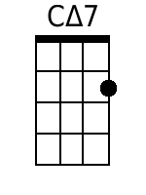 | 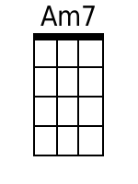 |  | 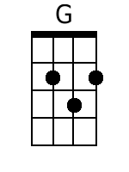 |  |  | 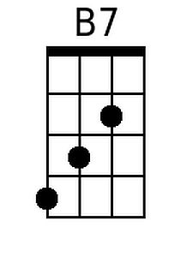 | 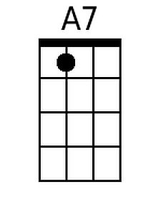
Bari
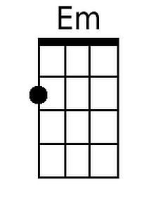 | 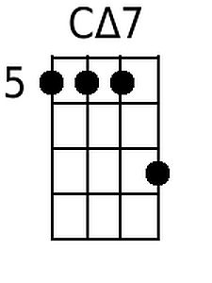 | 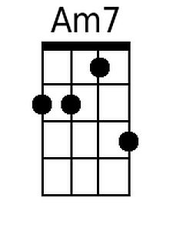 |  | 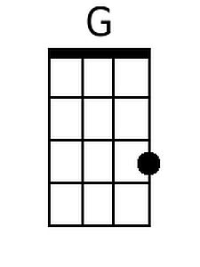 |  |  | 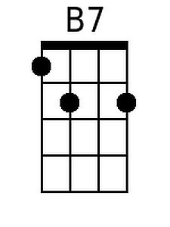 | 