
My Favorite Things
C74 Am
(Richard Rogers & Oscar Hammerstein from “The Sound of Music,” 1959)
My Favorite Things by Julie Andrews from the 1965 movie “The Sound of Music”

Am  Raindrops on roses and whiskers on kittens  F  Bright copper kettles and warm woolen mittens  Dm G7 C F  Brown paper packages tied up with string  C F Bm E7  These are a few of my favorite things.  Am  Cream colored ponies and crisp apple strudels  F  Doorbells and sleigh bells and schnitzel with noodles  Dm G7 C F  Wild geese that fly with the moon on their wing  C F Bm E7  These are a few of my favorite things.  Am  Girls in white dresses with blue satin sashes  F  Snowflakes that stay on my nose and eyelashes  Dm G7 C F  Silver white winters that melt into spring  C F Bm E7  These are a few of my favorite things.  Am Dm E7 Am F  When the dog bites, when the bee stings, when I'm feeling sad.  F Dm Am Dm  I simply remember my favorite things,  Am Dm G7 C | C  And then I don’t feel so bad.  (Repeat entire song, extend last line to end with 1 added measure of C) |  |  |  |  |  |  |  | 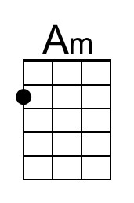
 |  |  |  |  |  |  |  | 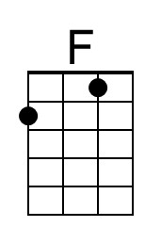
 |  |  |  |  |  |  |  | 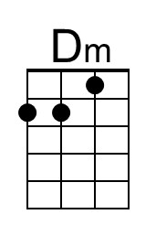
 |  |  |  |  |  |  |  | 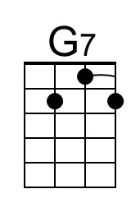
 |  |  |  |  |  |  |  | 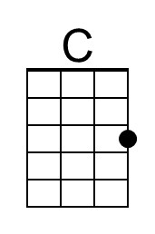
 |  |  |  |  |  |  |  | 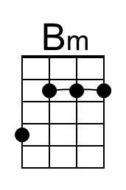
 |  |  |  |  |  |  |  | 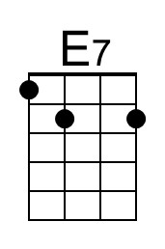
Baritone | 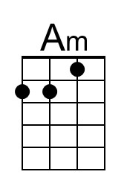 | 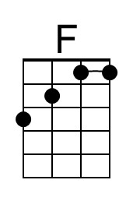 | 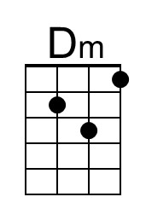 | 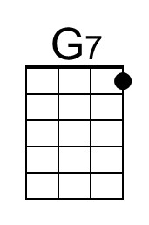 | 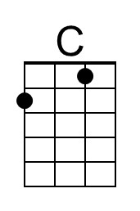 | 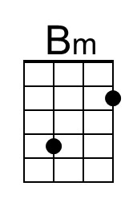 | 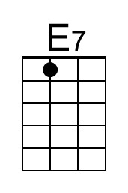

My Favorite Things
C74 Em
(Richard Rogers & Oscar Hammerstein from “The Sound of Music,” 1959)
My Favorite Things by Julie Andrews from the 1965 movie “The Sound of Music”

Em  Raindrops on roses and whiskers on kittens  C  Bright copper kettles and warm woolen mittens  Am D7 G C  Brown paper packages tied up with string  G C F#m B7  These are a few of my favorite things.  Em  Cream colored ponies and crisp apple strudels  C  Doorbells and sleigh bells and schnitzel with noodles  Am D7 G C  Wild geese that fly with the moon on their wing  G C F#m B7  These are a few of my favorite things.  Em  Girls in white dresses with blue satin sashes  C  Snowflakes that stay on my nose and eyelashes  Am D7 G C  Silver white winters that melt into spring  G C F#m B7  These are a few of my favorite things.  Em Am B7 Em C  When the dog bites, when the bee stings, when I'm feeling sad.  C Am Em Am  I simply remember my favorite things,  Em Am D7 G | G  And then I don’t feel so bad.  (Repeat entire song, extend last line to end with 1 added measure of C) |  |  |  |  |  |  |  | 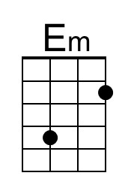
 |  |  |  |  |  |  |  | 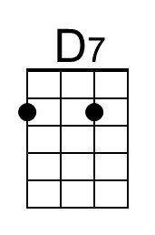
 |  |  |  |  |  |  |  | 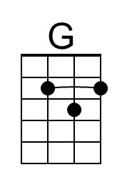
 |  |  |  |  |  |  |  | 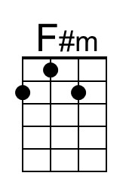
 |  |  |  |  |  |  |  | 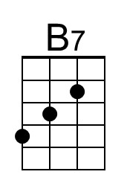
Baritone | 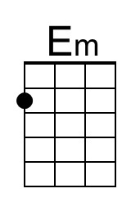 |  |  | 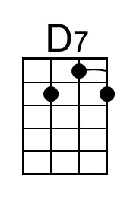 | 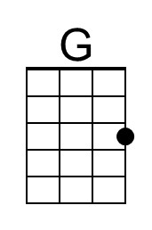 | 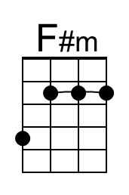 | 