My Favorite Things – Senor Version
Originally from the Broadway musical “The Sound of Music” by Richard Rogers and Oscar Hammerstein II (1959); USENET parody created, 2001. – ¾ Time – Key of Am

Intro (4 measures): Am

Am FΔ7
Maalox and nose drops and needles for knitting, Walkers and handrails and new dental fittings,
Dm7 G7 C F C F Dm E7 | Am | Am |
Bundles of magazines tied up in string, These are a few of my favorite things.
Am FΔ7
Cadillacs and cataracts, and hearing aids and glasses, Polident and Fixodent and false teeth in glasses,
Dm7 G7 C F C F Dm E7
Pacemakers, golf carts and porches with swings, These are a few of my favorite things.
Am Dm E7 Am F
When the pipes leak, when the bones creak, When the knees go bad,
F D7 C F C F - C | C | G7 C
I simply remember my favorite things, And then I don't feel so bad.

Am FΔ7
Hot tea and crumpets and corn pads for bunions, No spicy hot food or food cooked with onions,
Dm7 G7 C F C F Dm E7 | Am | Am |
Bathrobes and heating pads and hot meals they bring, These are a few of my favorite things.
Am FΔ7
Back pains, confused brains, and no need for sinnin', Thin bones and fractures and hair that is thinnin',
Dm7 G7 C F C F Dm E7
And we won't mention our short, shrunken frames, When we re-member our favorite things.
Am Dm E7 Am F
When the joints ache, When the hips break, When the eyes grow dim,
F D7 C F C F - C | C | G7 C | C | F | F | C | G7 | C
Then I remember the great life I've had, And then I don't feel . . . . . so bad.

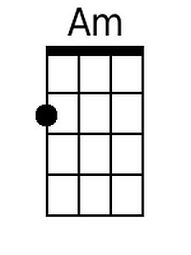 | 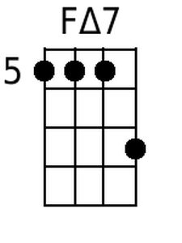 | 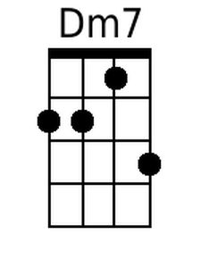 | 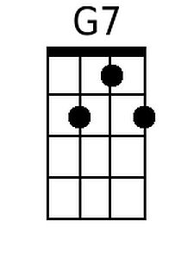 | 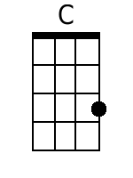 | 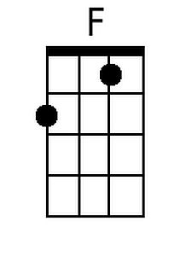 | 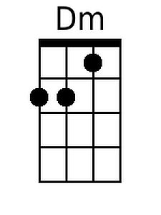 | 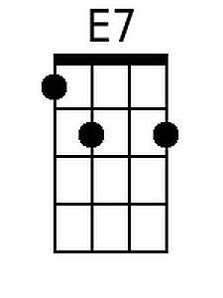 | 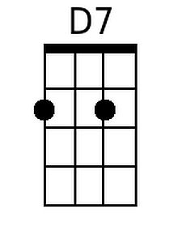
Bari
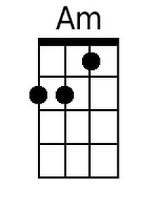 | 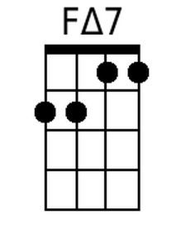 | 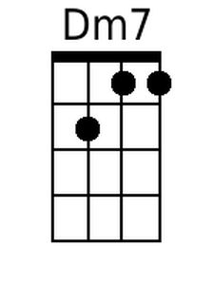 | 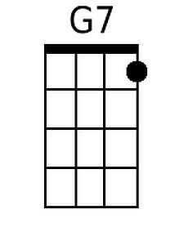 | 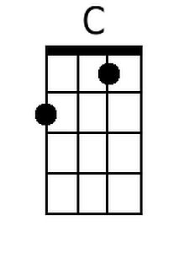 | 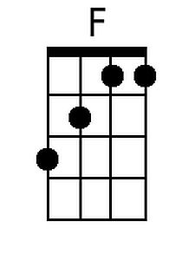 | 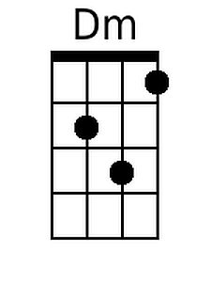 | 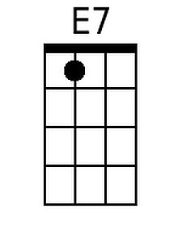 | 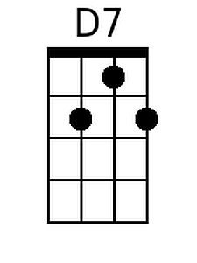

Note: There is a hoax that periodically appears on the World Wide Web concerning this parody. The story asserts that Julie Andrews sang this song at Radio City Music Hall for the benefit of the AARP. Not true. These lyrics first appeared in a 2001 Usenet group, four years after Julie Andrews underwent botched surgery on her vocal cords which resulted in the loss of her magnificant four-octave singing voice. As a result of subsequent surgeries, her speaking voice has been repaired, and she continues to have an active career. The hoax first appeared in July 2001. See: My Favorite Things - Senior Version, The Hymns and Carols of Christmas; My Favorite Things, Snopes.com; Julie Andrews, Wikipedia.

My Favorite Things – Senor Version
Originally from the Broadway musical “The Sound of Music” by Richard Rogers and Oscar Hammerstein II (1959); USENET parody created, 2001. – ¾ Time – Key of Em

Intro (4 measures): Em

Em CΔ7
Maalox and nose drops and needles for knitting, Walkers and handrails and new dental fittings,
Am7 D7 G C G C Am B7 | Em | Em |
Bundles of magazines tied up in string, These are a few of my favorite things.
Em CΔ7
Cadillacs and cataracts, and hearing aids and glasses, Polident and Fixodent and false teeth in glasses,
Am7 D7 G C G C Am B7
Pacemakers, golf carts and porches with swings, These are a few of my favorite things.
Em Am B7 Em C
When the pipes leak, when the bones creak, When the knees go bad,
C A7 G C G C – G | G | D7 G
I simply remember my favorite things, And then I don't feel so bad.

Em CΔ7
Hot tea and crumpets and corn pads for bunions, No spicy hot food or food cooked with onions,
Am7 D7 G C G C Am B7 | Em | Em |
Bathrobes and heating pads and hot meals they bring, These are a few of my favorite things.
Em CΔ7
Back pains, confused brains, and no need for sinnin', Thin bones and fractures and hair that is thinnin',
Am7 D7 G C G C Am B7
And we won't mention our short, shrunken frames, When we re-member our favorite things.
Em Am B7 Em C
When the joints ache, When the hips break, When the eyes grow dim,
C A7 G C G C – G | G | D7 G | G | C | C | G | D7 | G
Then I remember the great life I've had, And then I don't feel . . . . . . so bad.

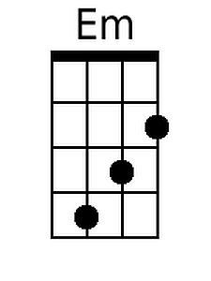 | 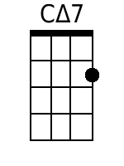 | 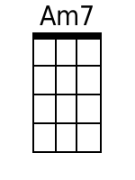 |  | 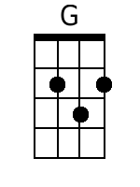 |  |  | 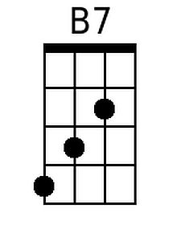 | 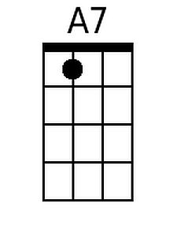
Bari
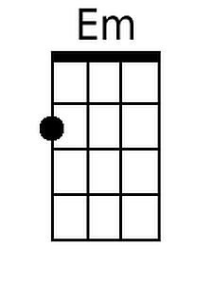 | 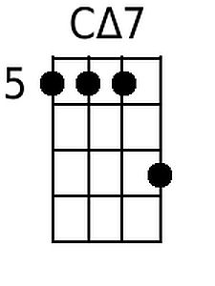 | 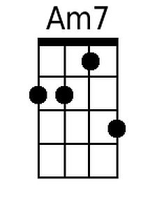 |  | 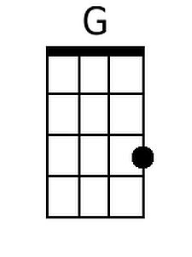 |  |  | 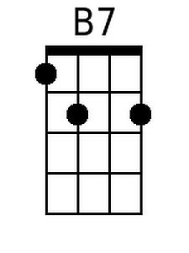 | 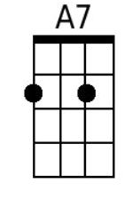

Note: There is a hoax that periodically appears on the World Wide Web concerning this parody. The story asserts that Julie Andrews sang this song at Radio City Music Hall for the benefit of the AARP. Not true. These lyrics first appeared in a 2001 Usenet group, four years after Julie Andrews underwent botched surgery on her vocal cords which resulted in the loss of her magnificant four-octave singing voice. As a result of subsequent surgeries, her speaking voice has been repaired, and she continues to have an active career. The hoax first appeared in July 2001. See: My Favorite Things - Senior Version, The Hymns and Carols of Christmas; My Favorite Things, Snopes.com; Julie Andrews, Wikipedia.

