**My Favorite Things (Richard Rogers / Oscar Hammerstein)**

**Am**

Raindrops on roses and whiskers on kittens

**F**

Bright copper kettles and warm woolen mittens

**Dm G7 C F**

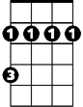

Bm



C

E7

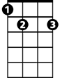

F

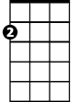

Am

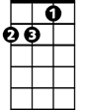

Dm

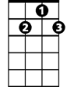

G7

Brown paper packages tied up with string s

**C F Bm E7**

These are a few of my favorite things

**Am**

Cream colored ponies and crisp apple strudels

**F**

Doorbells and sleigh bells and schnitzel with no odles

**Dm G7 C F**

Wild geese that fly with the moon on their wings

**C F Bm E7**

These are a few of my favorite things

**Am**

Girls in white dresses with blue satin sashes

**F**

Snowflakes that stay on my nose and eyelashes

**Dm G7 C F**

Silver white winters that melt into springs

**BARITONE**

**C F Bm E7**

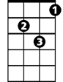

Dm

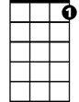

G7



Am



F

Bm

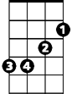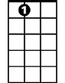

E7

These are a few of my favorite things

**Am**

When the dog bites

**Dm E7**

C



When the bee stings

**Am F**

When I'm feeling sad

**F Dm Am Dm**

I simply remember my favorite things

**Am Dm G7 C**

And then I don’t feel so bad

**(Repeat entire song, extend last line to end)**