**My Hula Girl (Randy Lorenzo)**

**D7 G7 C Eb C**

**C F C**

I look to see you dancing in the sunset

**D7 G7 C**

Telling stories with your hands, you smile and sway

**F C**

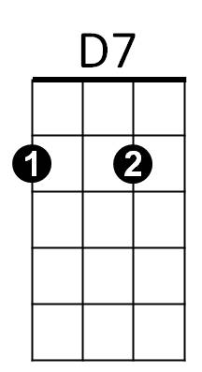You know that I would if I could, darling, give you the world

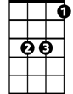

Eb

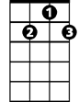

G7



C

**D7 G7 C**

I would give my heart and soul, my hula girl

**Eb C**

My hula girl

**C F C**

I dream that you and I will be together

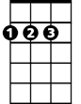

D

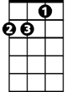

Dm

F



**D7 G7 C**

Making a wish on a rainbow, I stand in rainy weather

**F C**

In love with the way you move as your hands unfurl

**D7 G7 C**

I would do any thing for you, my hula girl

**Eb C**

My hula girl

**BARITONE**

C

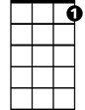

G7



D7

**D Eb F C**

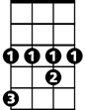

Eb

**Chorus:**

**F Eb**

Oh the beauty of your dance

**D**

I’d be thinking there’s a chance

**F C**

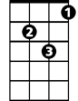

Dm



F



D

For a glance, my hula girl

**Dm C**

Oh my hula girl, yeah

**Instrumental verse**

**(1st verse and Chorus)**

**C D Eb F C**

My hula girl (my hula, hula girl)

**C D Eb F C**

My hula girl (dance hula, hula girl)

**C Dm C**

My hu-la (pause) girl