My Wild Irish Rose (Chauncey Olcott, 1899) Key C
Version 1

C F C  If you listen I'll sing you a sweet little song  D7 G  Of a flower that's now drooped and dead,  C F C  Yet dearer to me, yes than all of its mates,  G C  Though each holds a-loft its proud head.  F C  T’was given to me by a girl that I know,  Since we've met,  D7 G  Faith I've known no re-pose.  C  She is dearer by far  F C  Than the world's brightest star,  G C  And I call her my wild Irish Rose.  Chorus  C G C  My wild Irish Rose,  F G C  The sweetest flower that grows.  F C  You may search every-where,  F C  But none can com-pare  D D7 G  With my wild Irish Rose.  C G C  My wild Irish Rose,  F G C  The dearest flower that grows,  F C  And some day for my sake,  F C  She may let me take  D7 G C  The bloom from my wild Irish Rose. | C  They may sing of their roses,  F C  Which by other names,  D7 G  Would smell just as sweetly, they say.  C  But I know that my Rose  F C  Would never con-sent  G C  To have that sweet name taken a-way.  F C  Her glances are shy when e'er I pass by  D7 G  The bower where my true love grows,  C  And my one wish has been  F C  That some-day I may win  G C  The heart of my wild Irish Rose. Chorus
 | 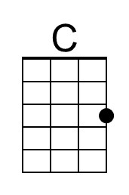 | 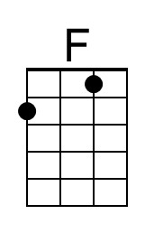 | 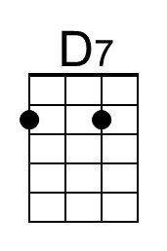 | 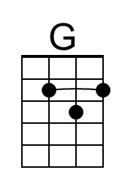 | 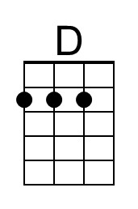
 | 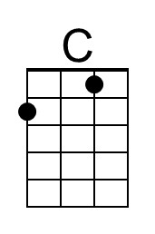 | 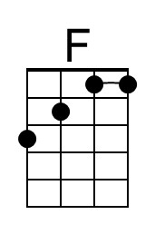 | 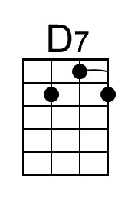 | 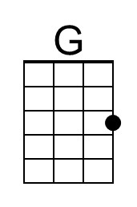 | 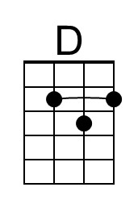

My Wild Irish Rose (Chauncey Olcott, 1899) Key G
Version 1

G C G  If you listen I'll sing you a sweet little song  A7 D  Of a flower that's now drooped and dead,  G C G  Yet dearer to me, yes than all of its mates,  D G  Though each holds a-loft its proud head.  C G  T'was given to me by a girl that I know,  Since we've met,  A7 D  Faith, I've known no re-pose.  G  She is dearer by far  C G  Than the world's brightest star,  D G  And I call her my wild Irish Rose.  Chorus  G D G  My wild Irish Rose,  C D G  The sweetest flower that grows.  C G  You may search every-where,  C G  But none can com-pare  A A7 D  With my wild Irish Rose.  G D G  My wild Irish Rose,  C D G  The dearest flower that grows,  C G  And some day for my sake,  C G  She may let me take  A7 D G  The bloom from my wild Irish Rose. | G  They may sing of their roses,  C G  Which by other names,  A7 D  Would smell just as sweetly, they say.  G  But I know that my Rose  C G  Would never con-sent  D G  To have that sweet name taken a-way.  C G  Her glances are shy when e'er I pass by  A7 D  The bower where my true love grows,  G  And my one wish has been  C G  That some-day I may win  D G  The heart of my wild Irish Rose. Chorus
 |  |  | 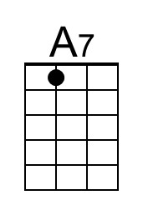 |  | 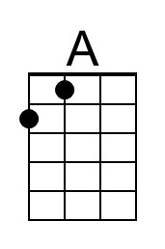
 |  |  | 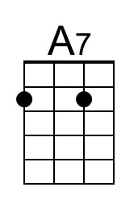 |  | 