My Wild Irish Rose (Chauncey Olcott, 1899) Key C
Version 2

Intro C Caug F C D7 G7 C G7  C Caug F C  If you listen I'll sing you a sweet little song  D7 G7  Of a flower that's now drooped and dead  C Caug F C  Yet dearer to me, yes than all of its mates  G7 C  Though each holds aloft its proud head  F C  'Twas given to me by a girl that I know  D7 G7  Since we've met, faith, I've known no repose  C Caug F C  She is dearer by far than the world's brightest star  G7 C F C  And I call her my Wild Irish Rose  Chorus:  C G7 C C7  My Wild Irish Rose,  F G7 C  The sweetest flower that grows  G7 C  You may search everywhere,  G7 C  But none can compare  D D7 G G7  With my Wild Irish Rose  C G7 C C7  My Wild Irish Rose,  F G7 C  The dearest flower that grows  G7 C  And some day for my sake,  G7 C  She may let me take  D7 G7 C  The bloom from my Wild Irish Rose |  |  |  |  | C Caug  They may sing of their roses,  F C  Which by other names  D7 G7  Would smell just as sweetly, they say  C Caug F C  But I know that my Rose would never consent  G7 C  To have that sweet name taken away  F C  Her glances are shy when-e'er I pass by  D7 G7  The bower where my true love grows  C Caug  And my one wish has been  F C  That someday I may win  G7 C F C  The heart of my Wild Irish Rose. Chorus  Outro  D7 G7 C  The bloom from my Wild Irish Rose
 |  |  |  |  | 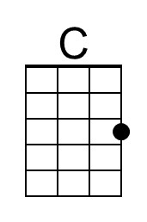 |  | 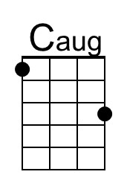 |  | 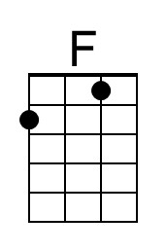 |  | 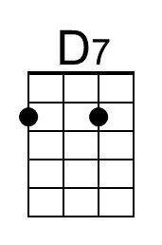
 |  |  |  |  | 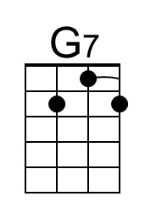 |  | 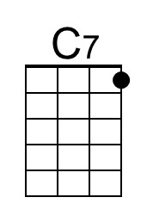 |  | 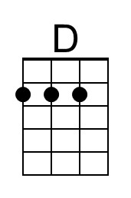 |  | 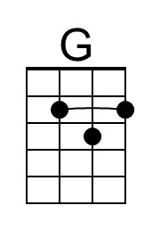
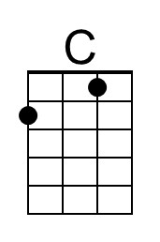 | 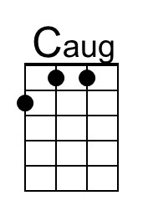 | 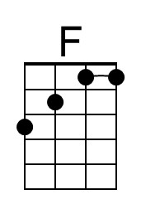 | 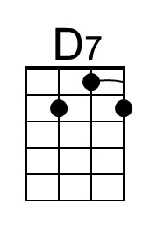 | 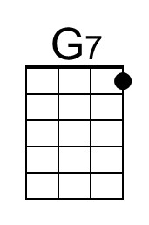 |  | 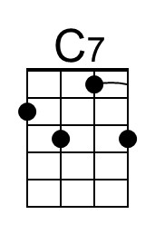 |  | 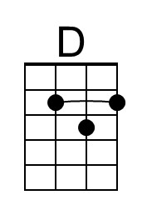 |  | 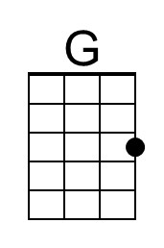

My Wild Irish Rose (Chauncey Olcott, 1899) Key G
Version 2

Intro G Gaug C G A7 D7 G D7  G Gaug C G  If you listen I'll sing you a sweet little song  A7 D7  Of a flower that's now drooped and dead  G Gaug C G  Yet dearer to me, yes than all of its mates  D7 G  Though each holds aloft its proud head  C G  'Twas given to me by a girl that I know  A7 D7  Since we've met, faith, I've known no repose  G Gaug C G  She is dearer by far than the world's brightest star  D7 G C G  And I call her my Wild Irish Rose  Chorus  G D7 G G7  My Wild Irish Rose,  C D7 G  The sweetest flower that grows  D7 G  You may search everywhere,  D7 G  But none can compare  A A7 D D7  With my Wild Irish Rose  G D7 G G7  My Wild Irish Rose,  C D7 G  The dearest flower that grows  D7 G  And some day for my sake,  D7 G  She may let me take  A7 D7 G  The bloom from my Wild Irish Rose |  |  |  |  | G Gaug  They may sing of their roses,  C G  Which by other names  A7 D7  Would smell just as sweetly, they say  G Gaug C G  But I know that my Rose would never consent  D7 G  To have that sweet name taken away  C G  Her glances are shy when-e'er I pass by  A7 D7  The bower where my true love grows  G Gaug  And my one wish has been  C G  That someday I may win  D7 G C G  The heart of my Wild Irish Rose Chorus  Outro  A7 D7 G  The bloom from my Wild Irish Rose
 |  |  |  |  |  |  | 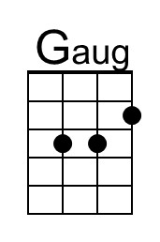 |  |  |  | 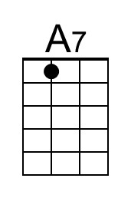
 |  |  |  |  |  |  |  |  | 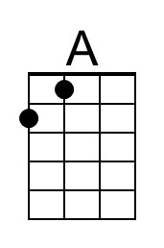
 | 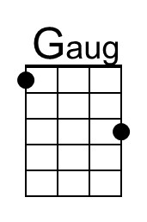 |  | 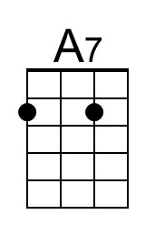 |  |  |  |  | 