**My Wild Irish Rose (Chauncey Olcott) (1899)**

**Intro: G Gaug C G A7 D7 G D7**

**G Gaug C G**

If you listen I'll sing you a sweet little song

**A7 D7**

Of a flower that's now drooped and dead

**G Gaug C G**

Yet dearer to me, yes than all of its mates

**D7 G**

Though each holds aloft its proud head

**C G**

'Twas given to me by a girl that I know

**A7 D7**

Since we've met, faith, I've known no repose

**G Gaug C G**

She is dearer by far than the world's brightest star

**D7 G C G**

And I call her my Wild Irish Rose

**Chorus:**

**G D7 G G7**

My Wild Irish Rose,

**C D7 G**

The sweetest flower that grows

**D7 G**

You may search everywhere,

**D7 G**

But none can compare



G

**A A7 D D7**

With my Wild Irish Rose

**G D7 G G7**

My Wild Irish Rose,

**C D7 G**

The dearest flower that grows

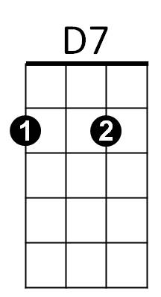 **D7 G**

And some day for my sake,

**D7 G**

She may let me take

**A7 D7 G**

The bloom from my Wild Irish Rose

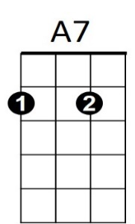

**BARITONE**

C



G

**G Gaug**

They may sing of their roses,

**C G**

Which by other names

**A7 D7**

Would smell just as sweetly, they say

**G Gaug C G**

But I know that my Rose would never consent

**D7 G**

To have that sweet name taken away

**C G**

Her glances are shy when-e'er I pass by

**A7 D7**

The bower where my true love grows

**G Gaug**

And my one wish has been

**C G**

That someday I may win

**D7 G C G**

The heart of my Wild Irish Rose

**(CHORUS)**

**A7 D7 G**

The bloom from my Wild Irish Rose

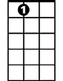

A7



C

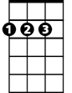

D

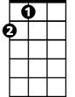

A

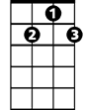

G7



D



A

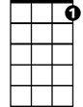

G7



D7