**My Yellow Ginger Lei *(Ku’u Lei ‘Awapuhi Melemele) Key C***

John Ka’onoho’i’okala Ke’awehawai’i

**VAMP D7 G7 C (2X)**

**C G7**

My yellow ginger lei

**C**

Reveals her scent through the day

**G7**

Enchanting moments with you

**C D7 G7 C**

Make me love y ou

**C G7**

Ku’u lei ‘awa puhi melemele

**C**

I pua me ke ‘ala onaona

**G7**

Ho’ohihi ka mana’o ia ‘oe

**C D7 G7 C**

E ku’u lei ‘awapuhi

**C G7**

You’re as lovely as can be

**C**

My yellow ginger lei

**G7**

My heart is yearning for you

**BARITONE**

**C D7 G7 C**

My ‘awapuhi

**C G7**

Haina ‘ia mai

**C**

Ana ka pu ana

**G7**

My yellow ginger lei

**C D7 G7 C**

Makes me love you

**G7**

My yellow ginger lei

**C D7 G7 C (2X)**

Makes me love you

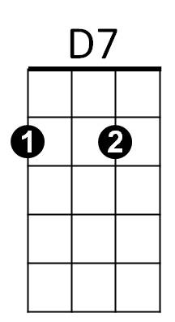



C

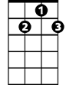

G7

C



D7

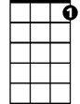

G7

**My Yellow Ginger Lei *(Ku’u Lei ‘Awapuhi Melemele) Key F***

John Ka’onoho’i’okala Ke’awehawai’i

**VAMP G7 C7 F (2X)**

**F C7**

My yellow ginger lei

**F**

Reveals her scent through the day

**C7**

Enchanting moments with you

**F G7 C7 F**

Make me love you

**F C7**

Ku’u lei ‘awa puhi melemele

**F**

I pua me ke ‘ala onaona

**C7**

Ho’ohihi ka mana’o ia ‘oe

**F G7 C7 F**

E ku’u lei ‘awapuhi

**F C7**

You’re as lovely as can be

**F**

My yellow ginger lei

**C7**

My heart is yearning for you



G7

**BARITONE**



F

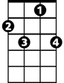

C7

**F G7 C7 F**

My ‘awapuhi

**F C7**

Haina ‘ia mai

**F**

Ana ka pu ana

**C7**

My yellow ginger lei

**F G7 C7 F**

Makes me love you

**C7**

My yellow ginger lei

**F G7 C7 F (2X)**

Makes me love you



G7

F



C7

**My Yellow Ginger Lei *(Ku’u Lei ‘Awapuhi Melemele) Key G***

John Ka’onoho’i’okala Ke’awehawai’i

**VAMP A7 D7 F (2X)**

**G D7**

My yellow ginger lei

**G**

Reveals her scent through the day

**D7**

Enchanting moments with you

**G A7 D7 G**

Make me love you

**G D7**

Ku’u lei ‘awa puhi melemele

**G**

I pua me ke ‘ala onaona

**D7**

Ho’ohihi ka mana’o ia ‘oe

**G A7 D7 G**

E ku’u lei ‘awapuhi

**G D7**

You’re as lovely as can be

**G**

My yellow ginger lei

**D7**

My heart is yearning for you

**BARITONE**

**G A7 D7 G**

My ‘awapuhi

**G D7**

Haina ‘ia mai

**G**

Ana ka pu ana

**D7**

My yellow ginger lei

**G A7 D7 G**

Makes me love you

**D7**

My yellow ginger lei

**G A7 D7 G (2X)**

Makes me love you

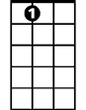

A7





G

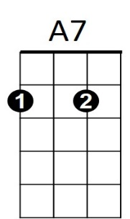



D7



G