Nashville Cats (John Sebastian) (G)

Intro G (Hold)  Chorus  G D G G7  Nashville Cats, play clean as country water  G D G G7  Nashville Cats, play wild as mountain dew  G D G G7  Nashville Cats, been playin' since they's babies  G D G G7 D  Nashville Cats, get work before they're two  G  Well, there's thirteen hundred and fifty two  D  Guitar pickers in Nashville  D  And they can pick more notes than the number  G of ants  On a Tennessee anthill  G  Yeah, there's thirteen hundred and fifty two  C  Guitar cases in Nashville  D  And any one that unpacks his guitar could play  G D  Twice as better than I will. |  |  |  | G  Yeah, I was just thirteen, you might say I was a  D  Musical proverbial knee-high  D  When I heard a couple new-sounding tunes on  G the tubes  And they blasted me sky-high  G  And the record man said every one is a yellow  C Sun  Record from Nashville  D  And up north there ain't nobody buys them  G D  And I said, but I will. And it was . . .  Chorus  G  Well, there's sixteen thousand eight hundred  D twenty one  Mothers from Nashville  D  All their friends play music, and they ain't uptight  G  If one of the kids will  G  Because it's custom made for any mother's son  C  To be a guitar picker in Nashville  D  And I sure am glad I got a chance to say a word  about  G D  The music and the mothers from Nashville . . .  Chorus  Outro  G C G D G
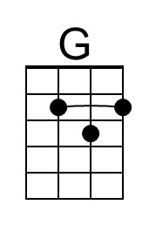 | 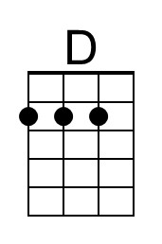 | 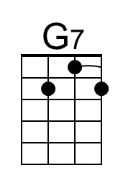 | 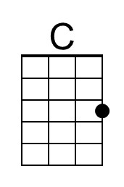 | 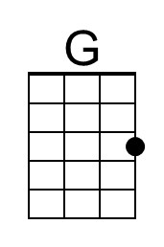 | 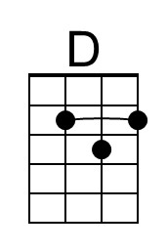 | 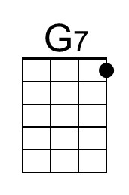 | 