**NEVER DID NO WANDERIN' (by The Folksmen from 'A Mighty Wind’)**

**Intro: Dm**

**Dm C Dm F A7**

My mama was the cold north wind, my daddy was the so-n,

**Dm C**

Of a rail road man, from west of Hell,

**Bb Am Dm**

Where the trains don't even run.

**F Dm**

Never heard the whistle of a South-bound freight,

**F A7**

Or the singing of it's drivin' wheel... no I...

**Chorus:**

**Dm C Dm F**

Never did no wanderin', never did no wanderin'.

**Dm A7 Dm**

Never did no wanderin' after all.

**Dm C**

They say the highway's just one big road,

**Dm F A7**

And it goes from here to the-re.

**Dm C**

And they say you carry a heavy load,

**Bb Am Dm**

When you're rollin' down the line some-where.

**F Dm**

Never seen the dance of the telephone poles,

**F A7**

As they go whizzin' by... no I...

**(Chorus)**

**Gm Dm Gm A7**

Never did no wanderin'... high……Never did no wanderin'... low.

**Dm C**

**BARITONE**

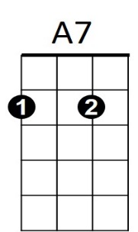Now a sailor’s life is a life for him,



F

C

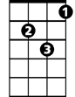

Dm

**Dm F A7**

But it never was for me-e.

**Dm C**

And I've never soared where the hawk may soar,

**Bb Am Dm**

Or seen what the hawk might see.

**F Dm**



D

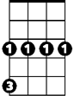

Gm

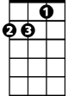

Am

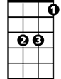

Bb

Never hiked to heaven on a mountain trail,

**F A7**

Never rolled on a river's rage... no I...

**(Chorus)**

**Outro: Dm A7 D**

Never did no wanderin' after all...