**Never, My Love (Don and Dick Addrisi, 1967) (C)**

**(Original key: C#)**

**Introductory Riff (E F G B C) (3x)**

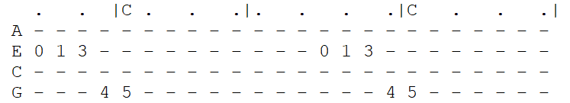

**C G Bb F C**

You ask me if there'll come a time when I grow tired of you.

**Am C F C**

Never, my love, never, my love. ***(-Riff------------)***

**C G Bb F C**

You wonder if this heart of mine will lose its de-sire for you.

**Am C F C**

Never, my love, never, my love.

**Chorus 1:**

**E7 Am D G C F**

What makes you think love will end when you know that my whole life de-pends

**Em7\ Am7\**

On you? *(on you)* ***(-Riff---------------)***

**C G Bb F C**

Da-ta-ta Da da da da Da------ Da-ta-ta Da-ta-ta da------

**Am C F C**

Never, my love, never, my love. ***(-Riff------------)***

**C . G . . . Bb . . . F . C .**

You say you fear I'll change my mind, and I won't re-- quire---- you

**Am C F C**

Never, my love, never, my love.

*(never, my love-------------) (never, my-- love---)*

**Chorus 2:**

**E7 Am D G C F**

How can you think love will end when I've asked you to spend your whole life

**Em7 Am7\ (Hold)**

With me? With me?

*(with me)*

**Outro (3x)**

**C G Bb F C**

***(-Riff------)***

**Am C F C**

Never, my love, never, my love.

*(never, my love) (never, my love)*

**Never, My Love (Don and Dick Addrisi, 1967) (G)**

**(Original key: C#)**

**Introductory Riff (B C D F# G) (3x)**

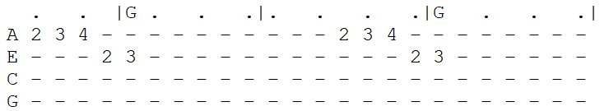

**G D F C G**

You ask me if there'll come a time when I grow tired of you.

**Em G C G**

Never, my love, never, my love. **(-Riff------------)**

**G D F C G**

You wonder if this heart of mine will lose its de-sire for you.

**Em G C G**

Never, my love, never, my love.

**Chorus 1:**

**B7 Em A D G C**

What makes you think love will end when you know that my whole life de-pends

**Bm7\ Em7\**

On you? (*on you*)  **(-Riff---------------)**

**G D F C G**

Da-ta-ta Da da da da Da------ Da-ta-ta Da-ta-ta da------

**Em G C G**

Never, my love, never, my love. **(-Riff------------)**

**G . D . . . F . . . C . G .**

You say you fear I'll change my mind, and I won't re-- quire---- you

**Em G C G**

Never, my love, never, my love.

(*never, my love*-------------) (*never, my-- love*---)

**Chorus 2:**

**B7 Em A D G C**

How can you think love will end when I've asked you to spend your whole life

**Em7 Am7\ (Hold)**

With me? With me?

(*with me*)

**Outro (3x)**

**G D F C G**

**(-Riff------)**

**Em G C G**

Never, my love, never, my love.

(*never, my love*) (*never, my love*)