**Never, My Love (Don and Dick Addrisi, 1967) (C)**

**(Original key: C#)**

**Introductory Riff (E F G B C) (3x)**

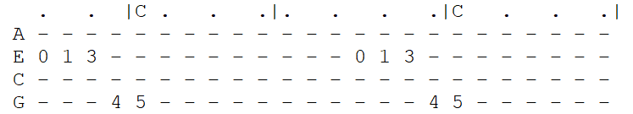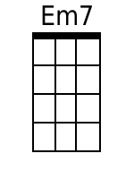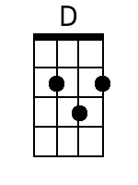

|  |  |  |  |  |  |  |  |  |  |
| --- | --- | --- | --- | --- | --- | --- | --- | --- | --- |
| **C G Bb F C**  You ask me if there'll come a time when I grow tired of you.  **Am C F C**  Never, my love, never, my love. *(-Riff------------)*  **C G Bb F C**  You wonder if this heart of mine will lose its de-sire for you.  **Am C F C**  Never, my love, never, my love.  **Chorus 1:**  **E7 Am D G C F**  What makes you think love will end when you know that my whole life de-pends  **Em7\ Am7\**  On you? *(on you) (-Riff---------------)*  **C G Bb F C**  Da-ta-ta Da da da da Da------ Da-ta-ta Da-ta-ta da------  **Am C F C**  Never, my love, never, my love. *(-Riff------------)*  **C G Bb F C**  You say you fear I'll change my mind, and I won't re-quire you  **Am C F C**  Never, my love, never, my love.  *(never, my love-------------) (never, my-- love---)*  **Chorus 2:**  **E7 Am D G C F**  How can you think love will end when I've asked you to spend your whole life  **Em7 Am7\ (Hold)**  With me? With me?  *(with me)*  **Outro (3x)**  **C G Bb F C**  *(-Riff------)*  **Am C F C**  Never, my love, never, my love.  *(never, my love) (never, my love)* | | | | | | | |  |  |
|  |  |
|  |  |
|  |  |
|  |  |
|  |  |
| **Bari** |  |  |  |  |  |  |  | |  |
|  |  |  |  |  |  |  |  | |  |

**Never, My Love (Don and Dick Addrisi, 1967) (G)**

**(Original key: C#)**

**Introductory Riff (B C D F# G) (3x)**

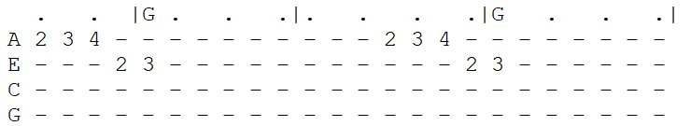

|  |  |  |  |  |  |  |  |  |  |
| --- | --- | --- | --- | --- | --- | --- | --- | --- | --- |
| **G D F C G**  You ask me if there'll come a time when I grow tired of you.  **Em G C G**  Never, my love, never, my love. **(-Riff------------)**  **G D F C G**  You wonder if this heart of mine will lose its de-sire for you.  **Em G C G**  Never, my love, never, my love.  **Chorus 1:**  **B7 Em A D G C**  What makes you think love will end when you know that my whole life de-pends  **Bm7\ Em7\**  On you? (*on you*)  **(-Riff---------------)**  **G D F C G**  Da-ta-ta Da da da da Da------ Da-ta-ta Da-ta-ta da------  **Em G C G**  Never, my love, never, my love. **(-Riff------------)**  **G D F C G**  You say you fear I'll change my mind, and I won't re-quire you  **Em G C G**  Never, my love, never, my love.  (*never, my love*-------------) (*never, my-- love*---)  **Chorus 2:**  **B7 Em A D G C**  How can you think love will end when I've asked you to spend your whole life  **Em7 Am7\ (Hold)**  With me? With me?  (*with me*)  **Outro (3x)**  **G D F C G**  **(-Riff------)**  **Em G C G**  Never, my love, never, my love.  (*never, my love*) (*never, my love*) | | | | | | | |  |  |
|  |  |
|  |  |
|  |  |
|  |  |
|  |  |
| **Bari** |  |  |  |  |  |  |  | |  |
|  |  |  |  |  |  |  |  | |  |