**New Kid in Town (Don Henley / Glenn Frey / John David Souther) Key F**

**F Gm C Gm C / Bb C F**

**F**

There's talk on the street,

**Gm C Gm C**

It sounds so famil - iar;

**Bb C F**

Great expectations, ev'rybody's watchin' you.

**C Bb C**

**F Gm C Gm C**

People you meet they all seem to know you,

**Bb C**

Even your old friends

**F Asus4 A7**

Treat you like you're somethin' new.

**Dm G Dm G**

Johnny come lately, the new kid in town.

**Dm G Gm C7**

Ev'rybody loves you, so don't let them down.

**F**

You look in her eyes,

**Gm C Gm C**

The music begins to play,

**Bb C F C Bb C**

Hopeless romantics, here we go again.

**F Gm C Gm C**

But after a while you're lookin' the other way,

**Bb C F Asus4 A7**

It's those restless hearts that never mend.

**Dm G Dm G**

Johnny come lately, the new kid in town.

**Dm G Gm C7**

Will she still love you - when you're not around?

**Bridge: F C / Bb C F / Bb F Gm F C7**

**C7 F**

There's so many things you should have told her,

**C7 Dm**

But night after night you're willing to hold her,

**G7 Bbm7 Eb Ab**

Just hold her, tears on your shoul - der.

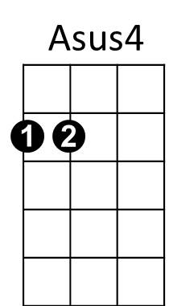

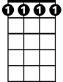

Bbm7

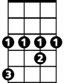

Ab

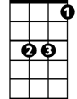

Eb

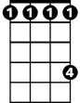

Db

**Ab**

There's talk on the street,

**Bbm7 Eb Bbm7 Eb**

It's there to remind you.

**Db Eb**

Doesn't really matter

**Ab Eb Db Eb**

Which side you're on.

**Ab**

You're walkin' away

**Bbm7 Eb Bbm7 Eb**

And they're talkin' behind you,

**Db Eb**

They will never forget you 'til somebody new

**Ab C7**

comes along.

**Fm Bb**

Where've you been lately?

**Fm Bb** T

here's a new kid in town.

**Fm Bb Bbm7**

Ev'rybody loves him (don't they?)

**C7 F**

And he's holdin' her and you're still around.

**Am7 Bb**

Ohhh ohh my my

**C7 F Am7 Bb**

There's a new kid in town, Ah, ah, ah

**C7 F Am7 Bb Bbm7**

just another new kid in town. Ah, ah, ah ah

**F Dm**

(Oo-oo) Ev'rybody's talkin' 'bout the new kid in town.

**F Dm**

(Oo-oo) Ev'rybody's walkin' like the new kid in town.

**F**

There's a new kid in town, (I don't want to hear it)

**Dm**

There's a new kid in town, (I don't want to hear it)

**BARITONE**

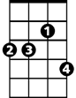

Bbm7



Ab

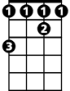

Db



Eb