**New Year's Day - U2**

**Am C Em**

Em

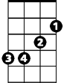

C

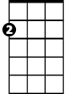

Am

All is quiet on New Year's Day

**Am C Em**

A world in white, gets underway

**Am C Em**

I want to be with you, be with you night and day

**Am C Em Am**

F



G

Nothing changes on New Year's Day

**Em**

On New Year's Day

**G Am**

I will be with you again

**G F Am C Em**

I will be with you again

**Am C Em**

Under a blood red sky

**Am C Em**

A crowd has gathered, black and white

**BARITONE**

C



**Am C Em**



Em

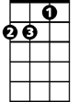

Am

Arms entwined, the chosen few

**Am C Em G**

Newspaper say, says, say it's true, it's true

**Am**

And we can break through



F



G

**G F**

Though torn in two, we can be one

**G Am**

I, I will begin again

**G F Am C Em Am**

I, I will begin again, yeah

**G Am**

I will be with you again

**G F Am C Em**

I will be with you again

**(fade out)**