New York Mining Disaster 1941 (Barry and Robin Gibbs, 1967)
Key Am, The Bee Gees

Intro (4 measures): Strum in on Am  Am  In the event of something happening to me  D7  There is something I would like you all to see  G Am D7  It's just a photograph of someone that I knew.  Chorus  G C G  Have you seen my wife Mr Jones?  C F  Do you know what it's like on the outside?  Dm E7 Am  Don't go talking too loud you'll cause a landslide, Mr. Jones.  Am  I keep straining my ears to hear a sound  D7  Maybe someone is digging under-ground  G Am  Or have they given up and all gone home to bed?  D7 G F  Thinking those who once existed must be dead? Chorus  Repeat Verse 1  G C G  Have you seen my wife Mr Jones?  C F  Do you know what it's like on the outside?  Dm E7  Don't go talking too loud you'll cause a landslide,  Am G F E7 Am | G | C | G  Mr. Jo - o - o – o - nes. |  |  |  |  |  |  |  | 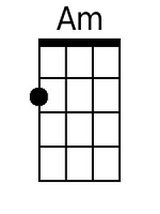
 |  |  |  |  |  |  |  | 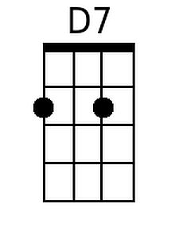
 |  |  |  |  |  |  |  | 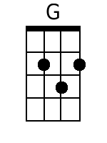
 |  |  |  |  |  |  |  | 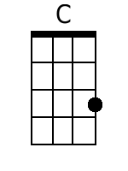
 |  |  |  |  |  |  |  | 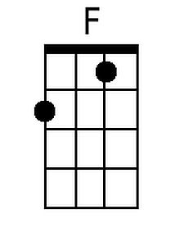
 |  |  |  |  |  |  |  | 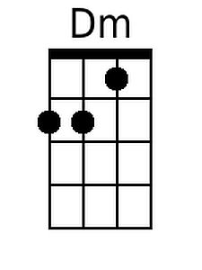
 |  |  |  |  |  |  |  | 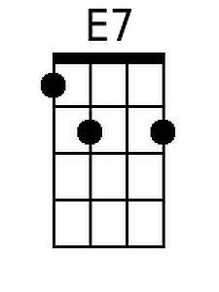
Baritone
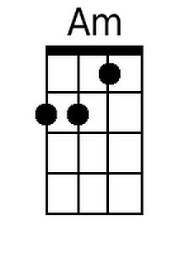 | 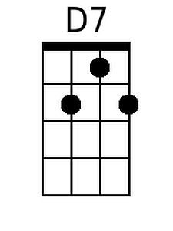 | 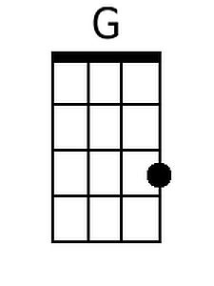 | 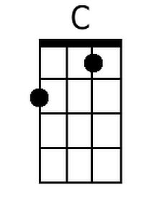 | 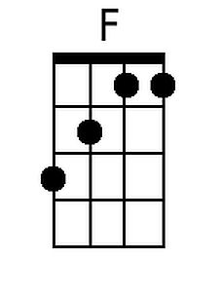 | 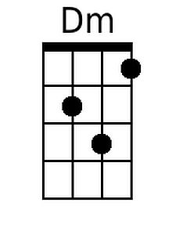 | 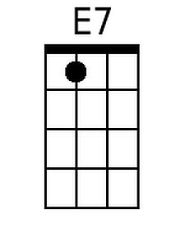

New York Mining Disaster 1941 (Barry and Robin Gibbs, 1967)
Key Em, The Bee Gees

Intro (4 measures): Strum in on Em  Em  In the event of something happening to me  A7  There is something I would like you all to see  D Em A7  It's just a photograph of someone that I knew.  Chorus  D G D  Have you seen my wife Mr Jones?  G C  Do you know what it's like on the outside?  Am B7 Em  Don't go talking too loud you'll cause a landslide, Mr. Jones.  Em  I keep straining my ears to hear a sound  A7  Maybe someone is digging under-ground  D Em  Or have they given up and all gone home to bed?  A7 D C  Thinking those who once existed must be dead? Chorus  Repeat Verse 1  D G D  Have you seen my wife Mr Jones?  G C  Do you know what it's like on the outside?  Am B7  Don't go talking too loud you'll cause a landslide  Em D C B7 Em | D | G | D  Mr Jo - o - o - o - nes. |  |  |  |  |  |  |  | 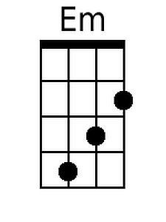
 |  |  |  |  |  |  |  | 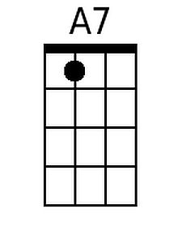
 |  |  |  |  |  |  |  | 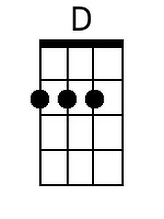
 |  |  |  |  |  |  |  | 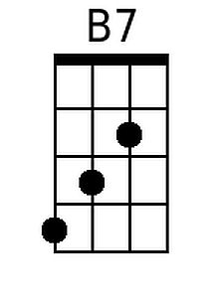
Baritone
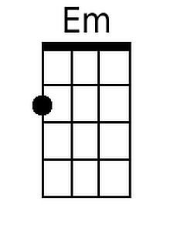 | 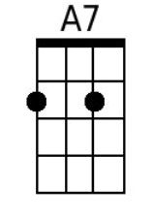 | 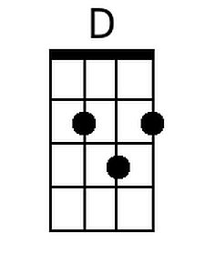 |  |  |  | 