New York Mining Disaster 1941 (Barry Gibb & Robin Gibb, 1967) (Am)
New York Mining Disaster 1941 by The Bee Gees (Am @ 89)

Intro Am ↓ ↓ ↓ ↓ | Am ↓ ↓ ↓ (Straight strum)  Am  In the event of something happening to me  D  There is something I would like you all to see  G Am/D  It's just a photograph of someone that I knew.  Chorus  G C G  Have you seen my wife, Mr. Jones?  G C F  Do you know what it's like on the outside?  Esus4 - E  Don't go talking too loud, you'll cause a landslide,  Am ↓ ↓ ↓ ↓ | Am ↓  Mr. Jones.  Last Time*:  Am ↓ Am/G ↓ Am/F ↓ Am/E ↓ Am/D  Mr. Jones . . .  Am  I keep straining my ears to hear a sound  D  Maybe someone is digging under-ground  G Am/D  Or have they given up and all gone home to bed?  D G - F  Thinking those who once existed must be dead. Chorus  Am  In the event of something happening to me  D  There is something I would like you all to see  G Am/D - D  It's just a photograph of someone that I knew. Chorus  _____________________  * Outro – Five beats of Am chord or this progression:  Am ↓ Am7 ↓ FmM7 ↓ Am ↓ D7sus2 ↓ | 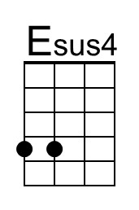
 | 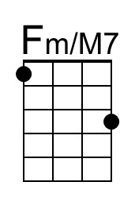
 | 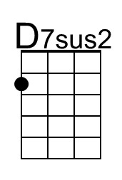
 | Bari
 | 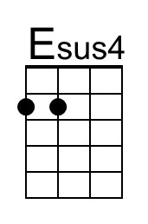
 | 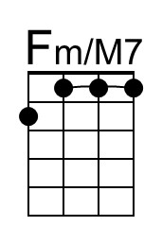
 | 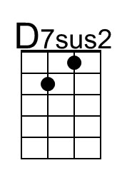

New York Mining Disaster 1941 (Barry Gibb & Robin Gibb, 1967) (Em)
New York Mining Disaster 1941 by The Bee Gees (Am @ 89)

Intro Am ↓ ↓ ↓ ↓ | Am ↓ ↓ ↓ (Straight strum)  Em  In the event of something happening to me  A  There is something I would like you all to see  D Em/A  It's just a photograph of someone that I knew.  Chorus  D G D  Have you seen my wife, Mr. Jones?  D G C  Do you know what it's like on the outside?  Bsus4 - B  Don't go talking too loud, you'll cause a landslide,  Em ↓ ↓ ↓ ↓ | Em ↓  Mr. Jones.  Last Time*:  Em ↓ Em/D ↓ Em/C ↓ Em/B ↓ Em/A  Mr. Jones . . .  Em  I keep straining my ears to hear a sound  A  Maybe someone is digging under-ground  D Em/A  Or have they given up and all gone home to bed?  A D - C  Thinking those who once existed must be dead. Chorus  Em  In the event of something happening to me  A  There is something I would like you all to see  D Em/A - A  It's just a photograph of someone that I knew. Chorus  _____________________  * Outro – Five beats of Em chord or this progression:  Em ↓ Em7 ↓ CmM7 ↓ Em ↓ A7sus2 ↓ | 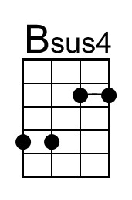
 | 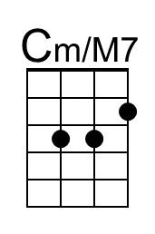
 | 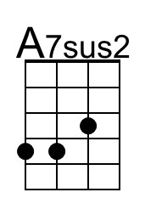
 | Bari
 | 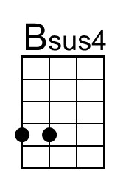
 | 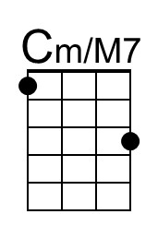
 | 