**New York, New York (John Kander & Fred Ebb, 1977)**

**Key C – Liza Minnelli Version (1977)**

F



G



C

**C G F 3x / C (let ring out)**

**G C (GFC) Dm G**

Start spreading the news, I'm leaving today

**C Dm G**

I want to be a part of it - New York, New York

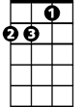

Dm

**G C (GFC) Dm G**

These vagabond shoes, are longing to stray

**C C7**

Right through the very heart of it - New York, New York

**F Fm C**

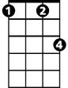

Fm

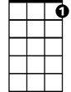

C7

I want to wake up in a city that doesn't sleep

**Em A7 Dm G**

And find I'm king of the hill - top of the heap

**C (GFC) Dm G**

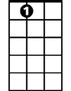

A7

Em

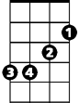

These little town blues, are melting away

**C C7**

I'II make a brand new start of it - in old New York

**F Fm C A7**

If I can make it there, I'll make it any-where

**Dm Em F G C C G F (3x)**

It's up to you - New York, New York

**(Repeat song from third line “These vagabond shoes…”,**

**Extend last two lines at ending, end with C)**

**BARITONE**

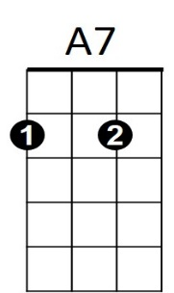

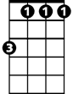

Fm

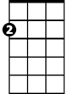

Em



F



G

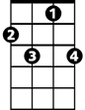

C7

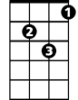

Dm

C



**New York, New York (John Kander & Fred Ebb, 1977)**

**Key G – Liza Minnelli Version (1977)**

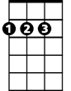

D



G

**G D C 3x / G (let ring out)**

**BARITONE**

**D G (DCG) Am D**

Start spreading the news, I'm leaving today

**G Am D**



Am



C

I want to be a part of it - New York, New York

**D G (DCG) Am D**

These vagabond shoes, are longing to stray

**G G7**

Right through the very heart of it - New York, New York

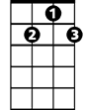

G7

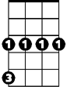

Cm

**C Cm G**

I want to wake up in a city that doesn't sleep

**Bm E7 Am D**

And find I'm king of the hill - top of the heap

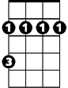

Bm

E7

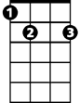

**G (DCG) Am D**

These little town blues, are melting away

**G G7**

I'II make a brand new start of it - in old New York

**C Cm G E7**

If I can make it there, I'll make it any-where

**Am Bm C D G G D C (3x)**

It's up to you - New York, New York

**(Repeat song from third line “These vagabond shoes…”,**

**Extend last two lines at ending, end in C)**

Bm



G7



E7



Cm



Am

C



D



G