New York, New York (John Kander & Fred Ebb, 1977)
Key of C – Frank Sinatra Version (1979)

Intro: C Dm C Dm

N.C. C  Start spreading the news  Dm  I'm leaving to-day  C  I want to be a part of it  Dm G  New York, New York  C  These vagabond shoes  Dm G  Are longing to stray  C  Right through the very heart of it  Gm7 C7  New York, New York  F  I want to wake up  Fm C  In a city that doesn't sleep  Em A7  And find I'm king of the hill  A7 Dm G  Top of the heap  C  These little town blues  Dm  Are melting a-way  C  I'll make a brand new start of it  Dm C7  In old New York  F Fm  If I can make it there  C A7  I'll make it any-where  Dm G Dm G C  It's up to you, New York, New York. |  |  |  |  |  |  | C Dm  N.C. F  I want to wake up  Fm C  In a city that never sleeps  Em A7  And find I'm A-number one  Em Dm Ab  Top of the list, King of the hill  G  A-number one  Slower tempo  N.C. C  These little town blues  Dm  Are melting a-way  C  I'll make a brand new start of it  Dm  In old New York  F Fm  If I can make it there  Em A7  I'll make it any-where  Dm  Come on through  G Dm G C  New York New Yooooooooork  Pause, then a quick strum for the next two chords  G C  New York |  |  |  |  |  |  |  |  | 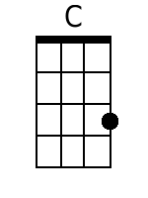 |  | 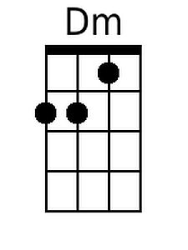
 |  |  |  |  |  |  |  |  |  |  |  |  |  |  |  | 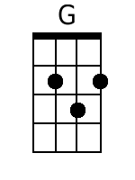 |  | 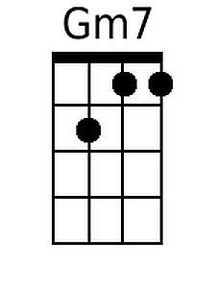
 |  |  |  |  |  |  |  |  |  |  |  |  |  |  |  | 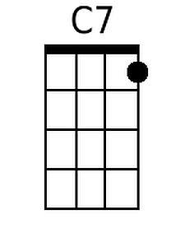 |  | 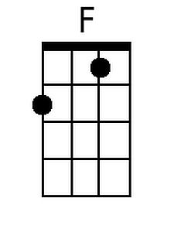
 |  |  |  |  |  |  |  |  |  |  |  |  |  |  |  | 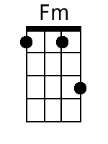 |  | 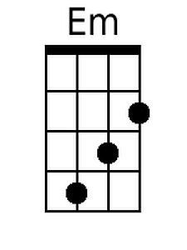
 |  |  |  |  |  |  |  |  |  |  |  |  |  |  |  | 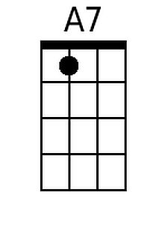 |  | 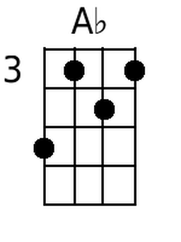
Baritone
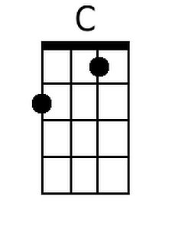 | 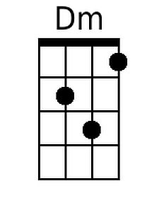 |  | 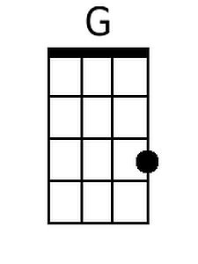 |  | 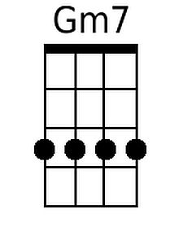 |  |  | 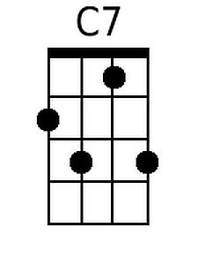 |  | 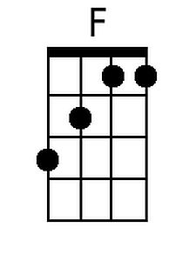 |  | 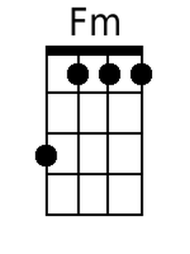 |  | 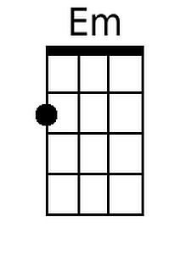 |  |  | 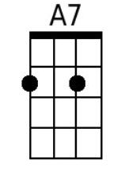 |  | 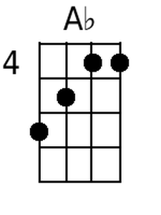

New York, New York (John Kander & Fred Ebb, 1977)
Key of G – Frank Sinatra Version (1979)

Intro: G Am G Am

N.C. G  Start spreading the news  Am  I'm leaving to-day  G  I want to be a part of it  Am D  New York, New York  G  These vagabond shoes  Am D  Are longing to stray  G  Right through the very heart of it  Dm7 G7  New York, New York  C  I want to wake up  Cm G  In a city that doesn't sleep  Bm E7  And find I'm king of the hill  E7 Am D  Top of the heap  G  These little town blues  Am  Are melting a-way  G  I'll make a brand new start of it  Am G7  In old New York  C Cm  If I can make it there  G E7  I'll make it any-where  Am D Am D G  It's up to you, New York, New York. |  |  |  |  |  |  | G Am  N.C. C  I want to wake up  Cm G  In a city that never sleeps  Bm E7  And find I'm A-number one  Bm Am Eb  Top of the list, King of the hill  D  A-number one  Slower tempo  N.C. G  These little town blues  Am  Are melting a-way  G  I'll make a brand new start of it  Am  In old New York  C Cm  If I can make it there  Bm E7  I'll make it any-where  Am  Come on through  D Am D G  New York New Yooooooooork  Pause, then a quick strum for the next two chords  D G  New York |  |  |  |  |  |  |  |  |  | 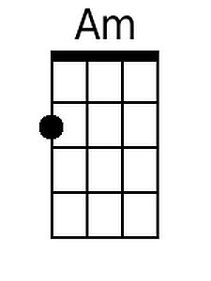
 |  |  |  |  |  |  |  |  |  |  |  |  |  |  | 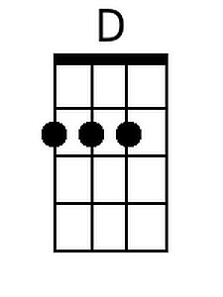 |  | 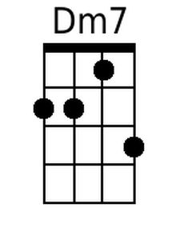
 |  |  |  |  |  |  |  |  |  |  |  |  |  |  | 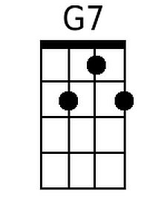
 |  |  |  |  |  |  |  |  |  |  |  |  |  |  | 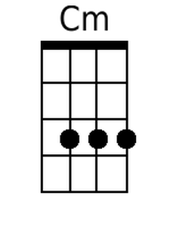 |  | 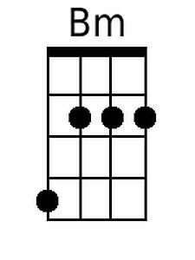
 |  |  |  |  |  |  |  |  |  |  |  |  |  |  | 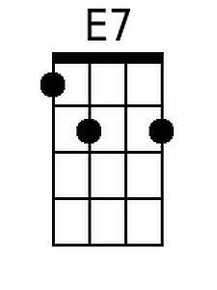 |  | 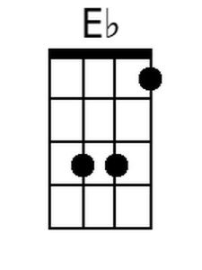
Baritone
 | 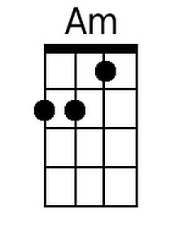 |  | 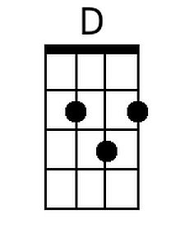 |  | 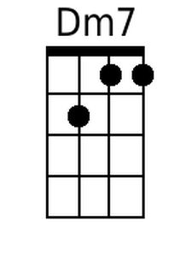 |  |  | 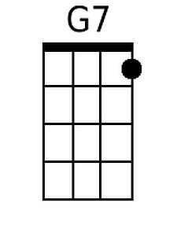 |  |  |  | 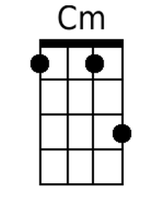 |  | 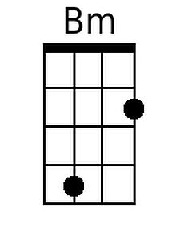 |  | 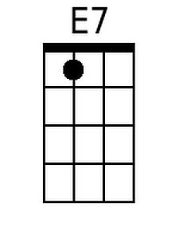 |  | 