**Nine Pound Hammer (Merle Travis) Key C**

**Intro: C F7 / C G7 C**

**C F7**

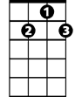

G7

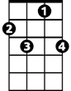

F7



C

This nine pound hammer is a little too heavy

**C G7 C**

Buddy for my size, buddy for my size

**C F7**

I'm going on the mountain, gonna see my baby

**C G7 C**

But I ain't coming back, no I ain't coming back

**Chorus:**

**C F7**

Roll on buddy, don't you roll so slow

**C G7 C**

How can I roll, when the wheels won't go

**C F7**

Roll on buddy, pull your load of coal

**C G7 C**

Now, how can I pull, when the wheels won't roll

**C F7**

**BARITONE**

This nine pound hammer, killed John Henry

**C G7 C**

But it won’t get me, ain’t a-gonna get me

**C F7**

C

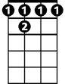

F7

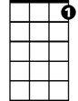

G7

Well I’m just a poor boy, a long ways from home

**C G7 C**

Down in Tennessee, down in Tennessee

**(Chorus)**

**C F7**

It's a long way to Harlan, it's a long way to Hazard

**C G7 C**

Just to get a little brew, just to get a little brew

**C F7**

Well when I’m long gone, just make my tombstone

**C G7 C**

Out of number nine coal, out of number nine coal

**(Chorus)**

**(Outro)**

**G7 C**

How can I roll, roll, roll, when the wheels won't go?

**Nine Pound Hammer (Merle Travis) Key G**

**Intro: G C7 / G D7 G**

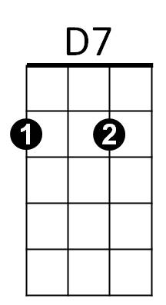 **G C7**



C7



G

This nine pound hammer is a little too heavy

**G D7 G**

Buddy for my size, buddy for my size

**G C7**

I'm going on the mountain, gonna see my baby

**G D7 G**

But I ain't coming back, no I ain't coming back

**Chorus:**

**G C7**

Roll on buddy, don't you roll so slow

**G D7 G**

How can I roll, when the wheels won't go

**G C7**

Roll on buddy, pull your load of coal

**G D7 G**

Now, how can I pull, when the wheels won't roll

**G C7**

This nine pound hammer, killed John Henry

**BARITONE**

**G D7 G**



C7



G



G7

But it won’t get me, ain’t a-gonna get me

**G C7**

Well I’m just a poor boy, a long ways from home

**G D7 G**

Down in Tennessee, down in Tennessee

**(Chorus)**

**G C7**

It's a long way to Harlan, it's a long way to Hazard

**G D7 G**

Just to get a little brew, just to get a little brew

**G C7**

Well when I’m long gone, just make my tombstone

**G D7 G**

Out of number nine coal, out of number nine coal

**(Chorus)**

**(Outro)**

**D7 G**

How can I roll, roll, roll, when the wheels won't go?