**No One Like You (Klaus Meine / Rudolf Schenker)**

**Intro: Chorus melody**



G

**Am F G Am**

F

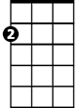

Am

Girl, it's been a long time that we've been apart

**F G Am**

Much too long for a man who needs love

**F C E7**

I miss you since I've been away

**Am F G Am**

E7

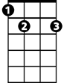

Babe, it wasn't easy to leave you alone



C

**F G Am**

It's getting harder now that I'm gone

**F C E7**

If I had the choice, I would stay

**Chorus:**

**Am**

There's no one like you

**F G Am**

I can't wait for the nights with you

**F G Am**

I imagine the things we do

**F G F E7**

I just wanna be loved by you



G

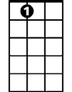

E7

**BARITONE**



F

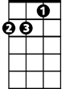

Am

C



**Am**

No one like you

**F G Am**

I can't wait for the nights with you

**F G Am**

I imagine the things we do

**F G F E7**

I just wanna be loved by you

**Am F G Am**

Girl, there are really no words strong enough

**F G Am**

To describe all my longing for love

**F C E7**

I don't want my feelings restrained

**Am F G Am**

Ooh, babe, I just need you like never before

**F G Am**

Just imagine you'd come through this door

**F C E7**

To take all my sorrow away

**(Chorus)**

**Am F G / Am F G / Am F C E7 2X (verse melody)**

**(Chorus) End with Am**