**No Sugar Tonight / New Mother Nature**



C

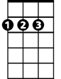

D

**Intro: C D G A x2 / D Dsus2 x6**

**Dsus2 D Dsus2 D Dsus2 D Dsus2 D**

Lonely feelin', deep inside, find a corner, where I can hide

**Dsus2 D Dsus2 D Dsus2 D Dsus2 D C A G F D**

Silent footsteps, crowdin' me, sudden darkness, but I can see



G

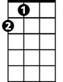

A

**Chorus 1**

**D C G D**

No sugar tonight in my coffee, no sugar tonight in my tea

**D C G D**

No sugar to stand beside me, no sugar to run with me

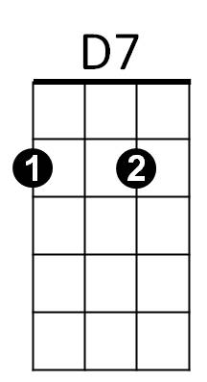**D C G D**

F



Dat'n-doo-dow dow-dat'n-doo-dow, dat'n-doo-dow dow-dow-dow

**D C G D C A G F D**

Dat'n-doo-dow dow-dat'n-doo-dow, dat'n-doo-dow dow

**D Dsus2 (x4)**

**Dsus2 D Dsus2 D Dsus2 D Dsus2 D**

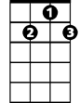

G7

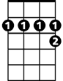

D7

In the silence, of her mind, quiet movements, where I can find

**Dsus2 D Dsus2 D Dsus2 D Dsus2 D C A G F D**

Grabbin' for me, with her eyes, now I'm fallin', from her skies

**(Chorus 1)**

**Interlude: ( C D G A ) x4 *simple chords or riff slowly**

**(D Dsus2 ) x4 ( D7 D7sus2) x2 (gradually build tempo)**

**D7 D7sus2 D7 D7sus2**

Jocko says yes and I believe him, when we talk about the things I say

**D7 D7sus2 D7 D7sus2**

She hasn't got the faith or the guts to leave him, when they're standing in each other's way

**D7 D7sus2 D7 D7sus2**

You're driven back in time to places you been to, you wonder what you're gonna find

**D7 D7sus2 D7**

You know you been wrong but it won't be long, before you leave 'em all far behind

**Chorus 2:**

**G7 D G7 D**

'Cause it's the new Mother Nature takin' over, it's the new splendid lady come to call

**G7 D C D C D**

It's the new Mother Nature takin' over, she's gettin' us all, she's gettin' us all

**D7sus2 D7 D7sus2 D7**

**D7 D7sus2 D7 D7sus2**

Jocko said no when I came back last time, it's lookin' like I lost a friend

**D7 D7sus2 D7 D7sus2**

No use callin' 'cause the sky is fallin' and I'm gettin' pretty near the end

**D7 D7sus2 D7 D7sus2**

A smoke-filled room in a corner basement, the situation must be right

**D7 D7sus2 D7**

A bag of goodies and a bottle of wine, we're gonna get it on right tonight

**(Chorus 2)**

**D7 D7sus2 D7 D7sus2**

Jocko says yes and I believe him, when we talk about the things I say

**D7 D7sus2 D7 D7sus2**

She hasn't got the faith or the guts to leave him, when they're standing in each other's way

**D7 D7sus2 D7 D7sus2**

You're driven back in time to places you been to, you wonder what you're gonna find

**D7 D7sus2 D7**

You know you been wrong but it won't be long, before you leave 'em all far behind

**(Chorus 2)**

**[Outro]**

**D C G D**

Dat'n-doo-dow dow-dat'n-doo-dow, dat'n-doo-dow dow-dow-dow

**D C G D**

Dat'n-doo-dow dow-dat'n-doo-dow, dat'n-doo-dow dow

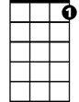

G7



D7



A



G



D

C



F

**BARITONE**