No, No Song (Hoyt Axton and David Jackson, ca. 1974)
No, No Song by Ringo Starr (1974)

A
Intro (four measures): (Ah, ah, ah, ah . . . Aye, yi, yi, yi)

A  A lady that I know just came from Columbia,  D A  she smiled because I did not under-stand.  D  Then she held out some mari-juana, ha ha!  E7 A  She said it was the best in all the land. And I said, | 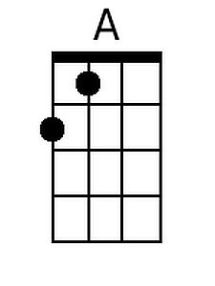 | 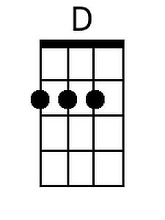 | 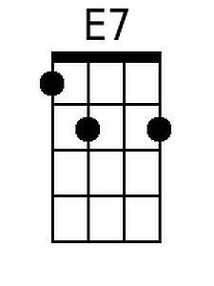
 | 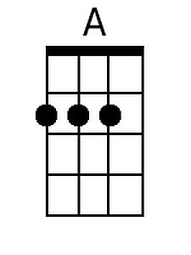 | 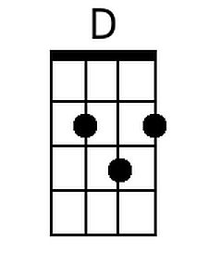 | 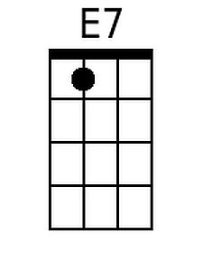

Chorus 1
A E7
No, no, no, no, I don't smoke it no more. I'm tired of waking up on the floor.
A
No, thank you, please, it only makes me sneeze, and then it makes it hard to find the door.
(Softly: Ah, ah, ah, ah)
A D A
A woman that I know just came from Majorca, Spain. She smiled because I did not under-stand.
D E7 A
Then she held out a ten pound bag of cocaine, she said it was the finest in the land. And I said,

Chorus 2
A E7
No, no, no, no, I don't -sniff- it no more. I'm tired of waking up on the floor.
A
No, thank you, please, it only makes me sneeze, then it makes it hard to find the door.
(Softly: Aye, yi, yi, yi) (4x)
A D A
A man I know just came from Nashville, Tennessee, oh. He smiled because I did not under-stand.
D E7 A
Then he held out some moonshine whiskey, oh ho, he said it was the best in all the land.
And he wasn’t joking

Chorus 3
A E7
And I said, No, no, no, no, I don't drink it no more. I'm tired of waking up on the floor.
A
No, thank you, please, it only makes me sneeze, and then it makes it hard to find the door.

Chorus 4
A E7)
Well, I said, No, no, no, no, I can't take it no more. I'm tired of waking up on the floor.
A ↓ | ↓
No, thank you, please, it only makes me sneeze, and then it makes it hard to find the door.

No, No Song (Hoyt Axton and David Jackson, ca. 1974) (C)
No, No Song by Ringo Starr (1974)

C
Intro (four measures): (Ah, ah, ah, ah . . . Aye, yi, yi, yi)

C  A lady that I know just came from Columbia,  F C  she smiled because I did not under-stand.  F  Then she held out some mari-juana, ha ha!  G7 C  She said it was the best in all the land. And I said, | 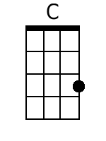 | 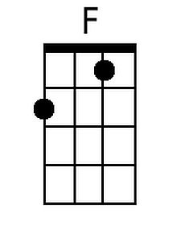 | 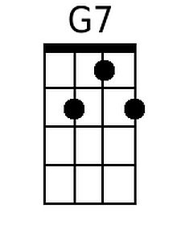
 | 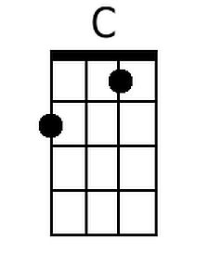 | 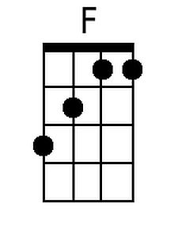 | 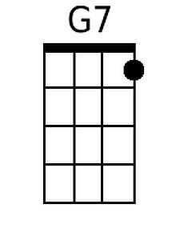

Chorus 1
C G7
No, no, no, no, I don't smoke it no more. I'm tired of waking up on the floor.
C
No, thank you, please, it only makes me sneeze, and then it makes it hard to find the door.
(Softly: Ah, ah, ah, ah)
C F C
A woman that I know just came from Majorca, Spain. She smiled because I did not under-stand.
F G7 C
Then she held out a ten pound bag of cocaine, she said it was the finest in the land. And I said,

Chorus 2
C G7
No, no, no, no, I don't -sniff- it no more. I'm tired of waking up on the floor.
C
No, thank you, please, it only makes me sneeze, then it makes it hard to find the door.
(Softly: Aye, yi, yi, yi) (4x)
C F C
A man I know just came from Nashville, Tennessee, oh. He smiled because I did not under-stand.
F G7 C
Then he held out some moonshine whiskey, oh ho, he said it was the best in all the land.
And he wasn’t joking

Chorus 3
C G7
And I said, No, no, no, no, I don't drink it no more. I'm tired of waking up on the floor.
C
No, thank you, please, it only makes me sneeze, and then it makes it hard to find the door.

Chorus 4
C G7
Well, I said, No, no, no, no, I can't take it no more. I'm tired of waking up on the floor.
C ↓ | ↓
No, thank you, please, it only makes me sneeze, and then it makes it hard to find the door.

No, No Song (Hoyt Axton and David Jackson, ca. 1974) (G)
No, No Song by Ringo Starr (1974)

G
Intro (four measures): (Ah, ah, ah, ah . . . Aye, yi, yi, yi)

G  A lady that I know just came from Columbia,  C G  she smiled because I did not under-stand.  C  Then she held out some mari-juana, ha ha!  D7 G  She said it was the best in all the land. And I said, | 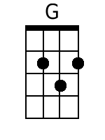 |  | 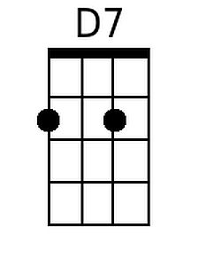
 | 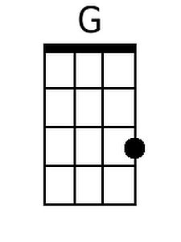 |  | 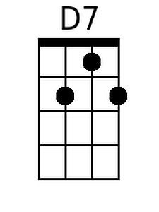

Chorus 1
G D7
No, no, no, no, I don't smoke it no more. I'm tired of waking up on the floor.
G
No, thank you, please, it only makes me sneeze, and then it makes it hard to find the door.
(Softly: Ah, ah, ah, ah)
G C G
A woman that I know just came from Majorca, Spain. She smiled because I did not under-stand.
C D7 G
Then she held out a ten pound bag of cocaine, she said it was the finest in the land. And I said,

Chorus 2
G D7
No, no, no, no, I don't -sniff- it no more. I'm tired of waking up on the floor.
G
No, thank you, please, it only makes me sneeze, then it makes it hard to find the door.
(Softly: Aye, yi, yi, yi) (4x)
G C G
A man I know just came from Nashville, Tennessee, oh. He smiled because I did not under-stand.
C D7 G
Then he held out some moonshine whiskey, oh ho, he said it was the best in all the land.
And he wasn’t joking

Chorus 3
G D7)
And I said, No, no, no, no, I don't drink it no more. I'm tired of waking up on the floor.
G
No, thank you, please, it only makes me sneeze, and then it makes it hard to find the door.

Chorus 4
G D7
Well, I said, No, no, no, no, I can't take it no more. I'm tired of waking up on the floor.
G ↓ | ↓
No, thank you, please, it only makes me sneeze, and then it makes it hard to find the door.

No, No Song (Hoyt Axton and David Jackson, ca. 1974)
No, No Song by Ringo Starr (1974)

1
Intro (four measures): (Ah, ah, ah, ah . . . Aye, yi, yi, yi)

1  A lady that I know just came from Columbia,  4 1  she smiled because I did not under-stand.  4  Then she held out some mari-juana, ha ha!  5(7) 1  She said it was the best in all the land. And I said, | 1 | 4 | 5(7)
 | A | D | E7
 | C | F | G7
 | D | G | A7
 | F | Bb | C7
 | G | C | D7

Chorus 1
1 5(7)
No, no, no, no, I don't smoke it no more. I'm tired of waking up on the floor.
1
No, thank you, please, it only makes me sneeze, and then it makes it hard to find the door.
(Softly: Ah, ah, ah, ah)
1 4 1
A woman that I know just came from Majorca, Spain. She smiled because I did not under-stand.
4 5(7) 1
Then she held out a ten pound bag of cocaine, she said it was the finest in the land. And I said,

Chorus 2
1 5(7)
No, no, no, no, I don't -sniff- it no more. I'm tired of waking up on the floor.
1
No, thank you, please, it only makes me sneeze, then it makes it hard to find the door.
(Softly: Aye, yi, yi, yi) (4x)
1 4 1
A man I know just came from Nashville, Tennessee, oh. He smiled because I did not under-stand.
4 5(7) 1
Then he held out some moonshine whiskey, oh ho, he said it was the best in all the land.
And he wasn’t joking

Chorus 3
1 5(7)
And I said, No, no, no, no, I don't drink it no more. I'm tired of waking up on the floor.
1
No, thank you, please, it only makes me sneeze, and then it makes it hard to find the door.

Chorus 4
1 5(7)
Well, I said, No, no, no, no, I can't take it no more. I'm tired of waking up on the floor.
1 ↓ | ↓
No, thank you, please, it only makes me sneeze, and then it makes it hard to find the door.

