**North Shore Serenade (Na Leo Pilimehana) Key C**

**C**

Come along take a ride to the Isle’s north side

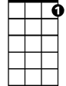

C7

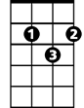

G

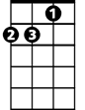

Dm

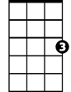

C

**Dm**

Through the winding ironwood trees

**G Dm G**

But be sure to take care no one follows you there

**C**

As you’re drifting along with the breeze

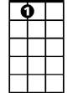

A7

F

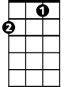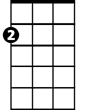

Am

For if anyone knew where I’m taking you to

**C7 F**

They’d surely never depart

**C Am**

The magical coast that I love the most

**Dm G C**

Nearest and dearest my heart

**Chorus:**

**F C**

Oh my oh me oh, take me down to the North Shore

**G C F C**

Where the white sand rolls in the pounding surf

**F C**

Yeah, why don’t we go, way on out to the North Shore

**G C A7**

**BARITONE**

Where the sky is blue and the ocean is too

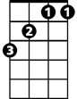

F

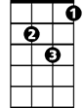

Dm



G

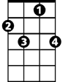

C7

C



**Dm G C**

Nearest to Heaven on Earth

**C**

Turn up the tunes, settle in for the ride

**G**

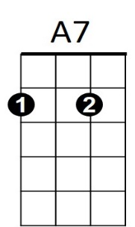And follow the sinking sun



Am

**Dm**

From the top of the hill the surf’s breaking still

**G C**

And my nerves gently start to unwind

Every mile that I drive brings me closer to where I’ve

**C7 F**

Always known I should be

**C Am**

It’s not a big city but the sugar cane’s pretty

**Dm G C**

My beautiful home by the sea

**(Chorus)**

**F C**

Ooooo—la la la la la North Shore **(3x to fade)**

**North Shore Serenade (Na Leo Pilimehana) Key F**

**F**

Come along take a ride to the Isle’s north side

**Gm**



Gm



F7



Dm



C



Bb

F



Through the winding ironwood trees

**C Gm C**

But be sure to take care no one follows you there

**F**

As you’re drifting along with the breeze

For if anyone knew where I’m taking you to

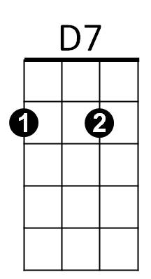 **F7 Bb**

They’d surely never depart

**F Dm**

The magical coast that I love the most

**Gm C F**

Nearest and dearest my heart

**Chorus:**

**Bb F**

Oh my oh me oh, take me down to the North Shore

**C F**

Where the white sand rolls in the pounding surf

**Bb F**

Yeah, why don’t we go, way on out to the North Shore

**C F D7**

**BARITONE**

Where the sky is blue and the ocean is too

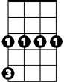

Gm



F

C

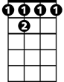

F 7

**Gm C F**

Nearest to Heaven on Earth

**F**

Turn up the tunes, settle in for the ride

**C**

And follow the sinking sun



Dm

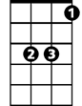

Bb

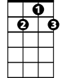

D7

**Gm**

From the top of the hill the surf’s breaking still

**C F**

And my nerves gently start to unwind

Every mile that I drive brings me closer to where I’ve

**F7 Bb**

Always known I should be

**F Dm**

It’s not a big city but the sugar cane’s pretty

**C F**

My beautiful home by the sea

**(Chorus)**

**Bb F**

Ooooo—la la la la la North Shore **(3x to fade)**

**North Shore Serenade (Na Leo Pilimehana)**

**G**



G7

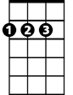

D



Am



G

Come along take a ride to the Isle’s north side

**Am**

Through the winding ironwood trees

**D Am D**

But be sure to take care no one follows you there

**G**

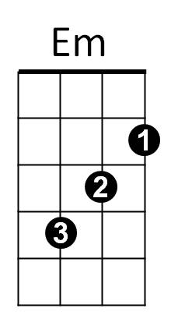As you’re drifting along with the breeze

E7

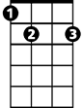

C

For if anyone knew where I’m taking you to

**G7 C**

They’d surely never depart

**G Em**

The magical coast that I love the most

**Am D G**

Nearest and dearest my heart

**Chorus:**

**C G**

Oh my oh me oh, take me down to the North Shore

**D G C G**

Where the white sand rolls in the pounding surf

**C G**

Yeah, why don’t we go, way on out to the North Shore

**D G E7**

Where the sky is blue and the ocean is too

**Am D G**

**BARITONE**

C



Am



G



E7



G7



Em



D

Nearest to Heaven on Earth

**G**

Turn up the tunes, settle in for the ride

**D**

And follow the sinking sun

**Am**

From the top of the hill the surf’s breaking still

**D G**

And my nerves gently start to unwind

Every mile that I drive brings me closer to where I’ve

**G7 C**

Always known I should be

**G Em**

It’s not a big city but the sugar cane’s pretty

**Am D G**

My beautiful home by the sea

**(Chorus)**

**C G**

Ooooo—la la la la la North Shore **(3x to fade)**