Tune for Mairi’s Wedding
Key of E

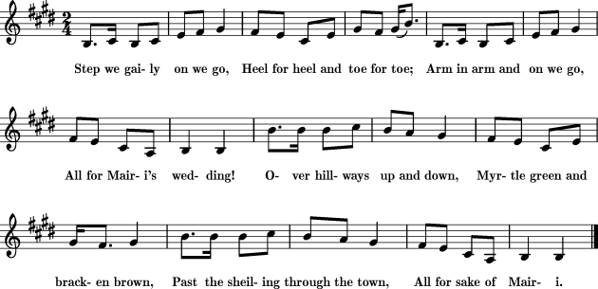
Source: Mairi’s Wedding, Mudcat Cafe (Accessed Feb. 22, 2023)

For additional details, see: Origins: Mairi’s Wedding, Mudcat Cafe (Accessed Feb. 22, 2023)

