O Christmas Tree
C75 C
“O Tannenbaum,” first verse attributed to August Zarnack, 1820;
second and third verses by Ernst Gebhard Anschutz, 1824
Translation by John Rutter (alt.)
O Tannenbaum by John Rutter and The Cambridge Singers

Intro (Chords of first line)  C G7 C Dm G7 G C  O Christmas tree, O Christmas tree, How faithful-ly you blossom!  C G7 C Dm G7 G C  O Christmas tree, O Christmas tree, How faithful-ly you blossom!  C F G7  Through summer’s heat and winter’s chill  Dm G7 C  Your leaves are green and blooming still.  C G7 C Dm G7 G C  O Christmas tree, O Christmas tree, How faithful-ly you blossom!  C G7 C Dm G7 G C  O Christmas tree, O Christmas tree, With what de-light I see you!  C G7 C Dm G7 G C  O Christmas tree, O Christmas tree, With what de-light I see you!  C F G7  When winter days are dark and drear  Dm G7 C  You bring us hope for all the year.  C G7 C Dm G7 G C  O Christmas tree, O Christmas tree, With what delight I see you!  C G7 C Dm G7 G C  O Christmas tree, O Christmas tree, you bear a joyful mess-age.  C G7 C Dm G7 G C  O Christmas tree, O Christmas tree, you bear a joyful message:  C F G7  That faith and hope shall ever bloom  Dm G7 C  To bring us light in winter’s gloom.  C G7 C Dm G7 G C  O Christmas tree, O Christmas tree, you bear a joyful message. | 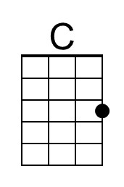 | 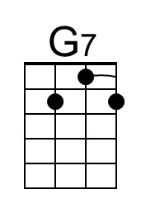
 | 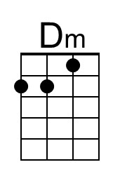 | 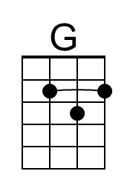
 | 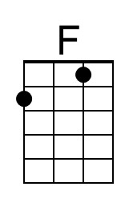
 | Baritone
 | 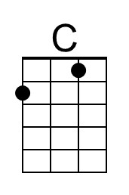 | 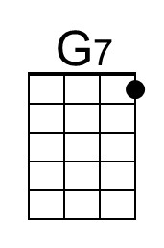
 | 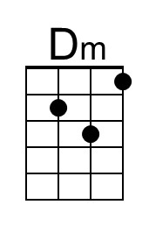 | 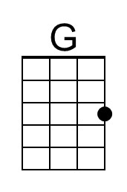
 | 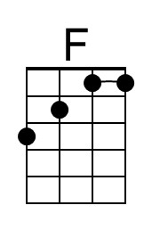

O Christmas Tree
C75 G
“O Tannenbaum,” first verse attributed to August Zarnack, 1820;
second and third verses by Ernst Gebhard Anschutz, 1824
Translation by John Rutter (alt.)
O Tannenbaum by John Rutter and The Cambridge Singers

Intro (Chords of first line)  G D7 G Am D7 D G  O Christmas tree, O Christmas tree, How faithful-ly you blossom!  G D7 G Am D7 D G  O Christmas tree, O Christmas tree, How faithful-ly you blossom!  G C D7  Through summer’s heat and winter’s chill  Am D7 G  Your leaves are green and blooming still.  G D7 G Am D7 D G  O Christmas tree, O Christmas tree, How faithful-ly you blossom!  G D7 G Am D7 D G  O Christmas tree, O Christmas tree, With what de-light I see you!  G D7 G Am D7 D G  O Christmas tree, O Christmas tree, With what de-light I see you!  G C D7  When winter days are dark and drear  Am D7 G  You bring us hope for all the year.  G D7 G Am D7 D G  O Christmas tree, O Christmas tree, With what delight I see you!  G D7 G Am D7 D G  O Christmas tree, O Christmas tree, you bear a joyful mess-age.  G D7 G Am D7 D G  O Christmas tree, O Christmas tree, you bear a joyful message:  G C D7  That faith and hope shall ever bloom  Am D7 G  To bring us light in winter’s gloom.  G D7 G Am D7 D G  O Christmas tree, O Christmas tree, you bear a joyful message. |  | 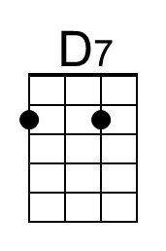
 | 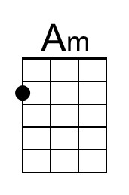
 | 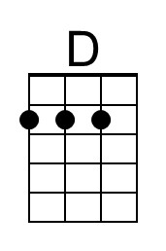
 | Baritone
 |  | 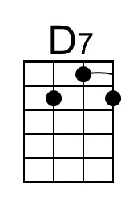
 | 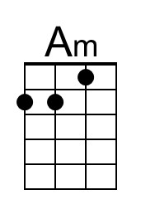
 | 