O Come, All Ye Faithful
C91 C
Words: "Adeste Fideles," John Francis Wade (c. 1711-1786), circa 1743 / 4; Translated by Frederick Oakeley (1802-1880), 1841. Music: "Adeste Fideles," John Francis Wade (c. 1711-1786), circa 1743.

Intro: Strum in on C  C G C G  1. Oh come, all ye faithful, Joyful and tri-umphant.  Am G D G  Oh come ye, oh come ye to Beth-lehem.  C F C F G  Come and be-hold him, Born the king of angels.  Refrain  C G C G  Oh come, let us adore Him. Oh come, let us adore Him.  F G C F C G C  Oh come, let us a-dore Hi-im, Chri-ist the Lord.  C G C G  2. Sing, choirs of angels, Sing in exul-tation.  Am G D G  Sing all ye citizens of hea-ven a-bove.  C F C F G  Glory to Go-od in the highest. Refrain  C G C G  3. Hail lord, we greet thee! Born this happy morning.  Am G D G C F C  Jesus to be the gl-or-ious, Word of the Fa-ther,  F G  Now in flesh ap-pearing. Refrain |  |  |  |  |  |  |  | 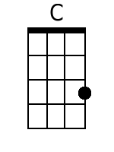
 |  |  |  |  |  |  |  | 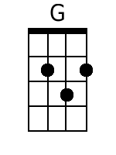
 |  |  |  |  |  |  |  | 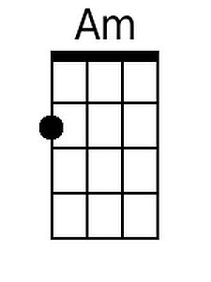
 |  |  |  |  |  |  |  | 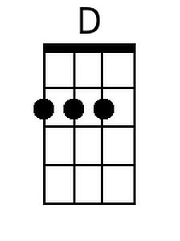
 |  |  |  |  |  |  |  | 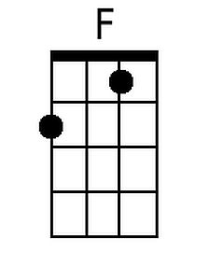
Baritone
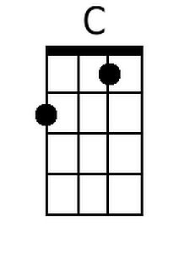 | 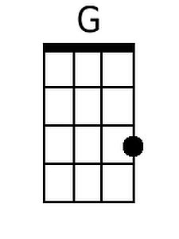 | 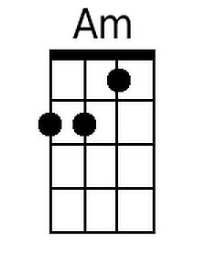 | 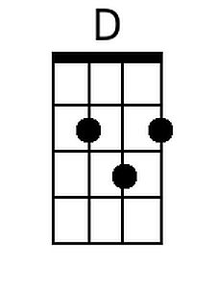 | 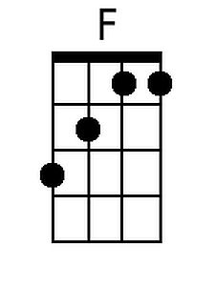

O Come, All Ye Faithful
C91 G
Words: "Adeste Fideles," John Francis Wade (c. 1711-1786), circa 1743 / 4; Translated by Frederick Oakeley (1802-1880), 1841. Music: "Adeste Fideles," John Francis Wade (c. 1711-1786), circa 1743.

Intro: Strum in on G

G D G D
1. Oh come, all ye faithful, Joyful and tri-umphant.
Em D A D
Oh come ye, oh come ye to Beth-lehem.
G C G C D
Come and be-hold him, Born the king of angels.

Refrain
G D G D
Oh come, let us adore Him. Oh come, let us adore Him.
C D G C G D G
Oh come, let us a-dore Hi-im, Chri-ist the Lord.

G D G D
2. Sing, choirs of angels, Sing in exul-tation.
Em D A D
Sing all ye citizens of hea-ven a-bove.
G C G C D
Glory to Go-od in the highest. Refrain

G D G D
3. Hail lord, we greet thee! Born this happy morning.
Em D A D G C G
Jesus to be the gl-or-ious, Word of the Fa-ther,
C D
Now in flesh ap-pearing. Refrain

 |  |  |  |  |  |  |  | 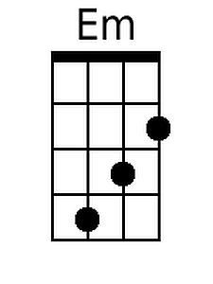
 |  |  |  |  |  |  |  | 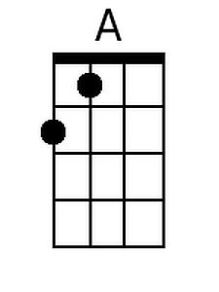
Baritone
 |  | 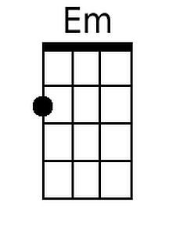 | 