O Come, O Come, Emmanuel
C92 Am
Words: “Veni, Veni, Emanuel” (the "O" Antiphons), Authorship Unknown, 8th Century Latin; English lyrics by John Mason Neale (1851); Music: "Veni Emmanuel," 15th Century French Processional (1854).

Intro Am Dm C (Last 3 chords of verse)  Am Dm C Am Dm Am  1. O come, O come, E–man–u–el, And ransom captive Is–ra–el.  Dm Am G Am Dm C  That mourns in lowly exile here, Un–til the Son of God ap–pear.  Refrain  G Am Dm Am  Re–joice! Re–joice! E–man–u–el  C Dm Am  Shall come to thee, O Is–rael.  Am Dm Am Am Dm Am  2. O come, Thou Rod of Jesse, free, Thine own from Satan's tyran - ny;  Dm Am G Am Dm C  From depths of hell Thy people save, And give them victory over the grave.  Refrain  Am Dm C Am Dm Am  3. O come, Thou Day-spring, come and cheer, Our spirits by Thine advent here;  Dm Am G Am Dm C  And drive away the shades of night, And pierce the clouds and bring us light!  Refrain  Am Dm C Am Dm Am  4. O come, Thou Key of David, come, And open wide our heavenly home;  Dm Am G Am Dm C  Make safe the way that leads on high, And close the path to miser-y. Refrain  Am Dm C Am Dm Am  5. O come, O come, Thou Lord of might, Who to Thy tribes on Sinai's height  Dm Am G Am Dm C  In ancient times once gave the law, In cloud, and majesty, and awe. Refrain |  |  |  |  |  |  |  | 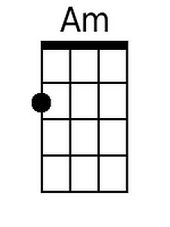
 |  |  |  |  |  |  |  | 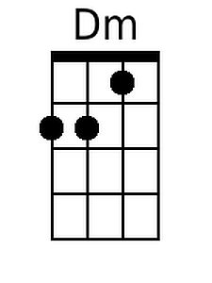
 |  |  |  |  |  |  |  | 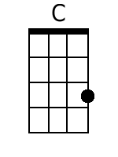
 |  |  |  |  |  |  |  | 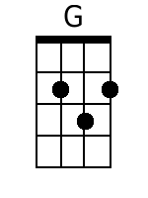
Baritone
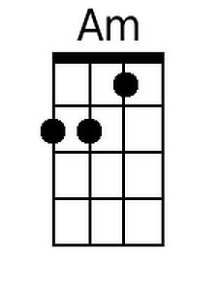 | 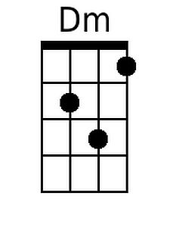 | 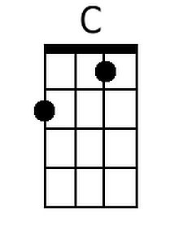 | 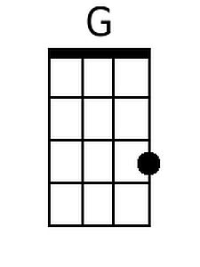

O Come, O Come, Emmanuel
C92 Em
Words: “Veni, Veni, Emanuel” (the "O" Antiphons), Authorship Unknown, 8th Century Latin; English lyrics by John Mason Neale (1851); Music: "Veni Emmanuel," 15th Century French Processional (1854).

Intro Em Am G (Last 3 chords of verse)  Em Am G Em Am Em  1. O come, O come, E-man-u-el, And ransom captive Is-ra-el.  Am Em D Em Am G  That mourns in lowly exile here, Un-til the Son of God ap-pear.  Refrain  D Em Am Em  Re-joice! Re-joice! E-man-u-el  G Am Em  Shall come to thee, O Is-rael.  Em Am Em Em Am Em  2. O come, Thou Rod of Jesse, free, Thine own from Satan's tyran - ny;  Am Em D Em Am G  From depths of hell Thy people save, And give them victory over the grave.  Refrain  Em Am G Em Am Em  3. O come, Thou Day-spring, come and cheer, Our spirits by Thine advent here;  Am Em D Em Am G  And drive away the shades of night, And pierce the clouds and bring us light!  Refrain  Em Am G Em Am Em  4. O come, Thou Key of David, come, And open wide our heavenly home;  Am Em D Em Am G  Make safe the way that leads on high, And close the path to miser-y. Refrain  Em Am G Em Am Em  5. O come, O come, Thou Lord of might, Who to Thy tribes on Sinai's height  Am Em D Em Am G  In ancient times once gave the law, In cloud, and majesty, and awe. Refrain |  |  |  |  |  |  |  | 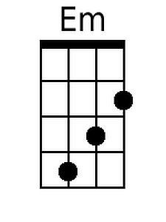
 |  |  |  |  |  |  |  | 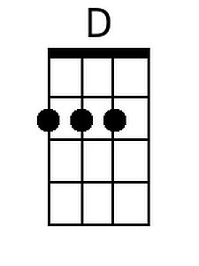
Baritone
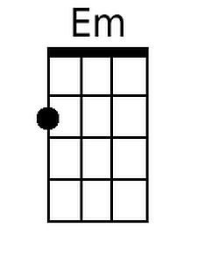 |  |  | 