O Holy Night
C33 C
Cantique de Noël by Placide Cappeau (1843), music by Adolphe Adam (1847);
English lyrics by John Sullivan Dwight (1855)

Intro C | F | C

C F C G7 C
O holy night, the stars are brightly shining. It is the night of our dear Savior's birth
F C - C7 Em B7 Em
Long lay the world in sin and error pining. 'Til He ap-peared and the soul felt its worth.
G7 C G7 C
A thrill of hope the weary world rejoices, for yonder breaks a new and glorious morn.
Am Em Dm Am C - G7 C - F
Fall on your knees, O hear the angels voices. O ni-ght ~ di-vine,
C G7 C G C - Dm C G7 C
O night when Christ was born. O night di-vi-ne, O night, O night di-vine.

C F C G7 C
Led by the light of Faith serenely beaming; With glowing hearts by his cradle we stand:
F C - C7 Em B7 Em
So, led by light of a star sweetly gleaming, here come the wise men from Orient land,
G7 C G7 C
The King of Kings lay thus in lowly manger, in all our trials born to be our friend;
Am Em Dm Am C -G7 C - F
He knows our need, To our weakness no stranger! Be-hold your King!
C G7 C G C - Dm C G7 C
Be-fore Him lowly bend! Be-hold your King! your King! before him bend!

C F C G7 C
Truly He taught us to love one an-other; His law is Love and His gospel is Peace;
F C - C7 Em B7 Em
Chains shall he break, for the slave is our brother, and in His name all op-pression shall cease,
G7 C G7 C
Sweet hymns of joy in grateful Chorus raise we; Let all within us praise his Holy name!
Am Em Dm Am C - G7 C - F C G7 C
Christ is the Lord, then ever! ever praise we! His pow'r and glory, ever-more pro-claim!
G C - Dm C G7 C
His pow'r and glory, ever-more pro-claim!

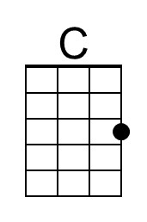 | 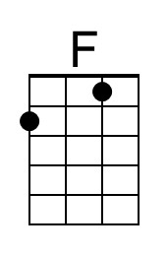 | 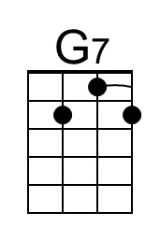 | 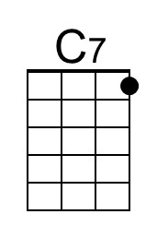 | 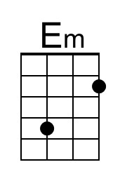 | 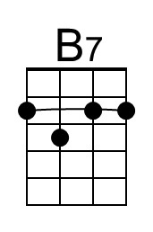 | 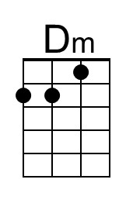 | 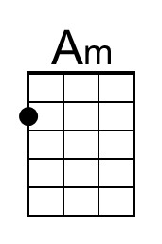 | 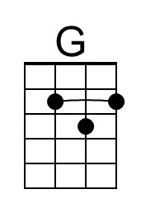
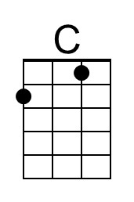 | 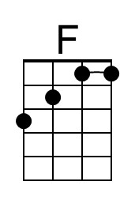 | 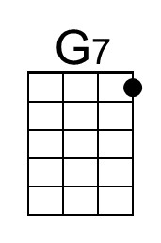 | 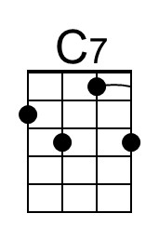 | 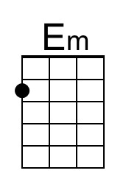 | 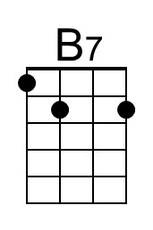 | 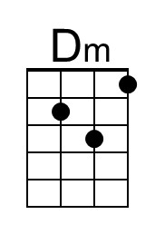 | 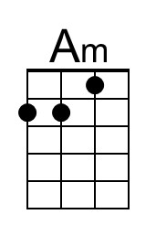 | 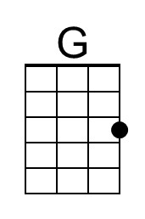

O Holy Night
C33 F
Cantique de Noël by Placide Cappeau (1843), music by Adolphe Adam (1847);
English lyrics by John Sullivan Dwight (1855)

Intro F | Bb | F

F Bb F C7 F
O holy night, the stars are brightly shining. It is the night of our dear Savior's birth
Bb F - F7 Am E7 Am
Long lay the world in sin and error pining. 'Til He ap-peared and the soul felt its worth.
C7 F C7 F
A thrill of hope the weary world rejoices, for yonder breaks a new and glorious morn.
Dm Am Gm Dm F - C7 F - Bb
Fall on your knees, O hear the angels voices. O ni-ght ~ di-vine,
F C7 F C F - Gm F C7 F
O night when Christ was born. O night di-vi-ne, O night, O night di-vine.

F Bb F C7 F
Led by the light of Faith serenely beaming; With glowing hearts by his cradle we stand:
Bb F - F7 Am E7 Am
So, led by light of a star sweetly gleaming, here come the wise men from Orient land,
C7 F C7 F
The King of Kings lay thus in lowly manger, in all our trials born to be our friend;
Dm Am Gm Dm F -C7 F - Bb
He knows our need, To our weakness no stranger! Be-hold your King!
F C7 F C F - Gm F C7 F
Be-fore Him lowly bend! Be-hold your King! your King! before him bend!

F Bb F C7 F
Truly He taught us to love one an-other; His law is Love and His gospel is Peace;
Bb F - F7 Am E7 Am
Chains shall he break, for the slave is our brother, and in His name all op-pression shall cease,
C7 F C7 F
Sweet hymns of joy in grateful Chorus raise we; Let all within us praise his Holy name!
Dm Am Gm Dm F - C7 F - Bb F C7 F
Christ is the Lord, then ever! ever praise we! His pow'r and glory, ever-more pro-claim!
C F - Gm F C7 F
His pow'r and glory, ever-more pro-claim!

 | 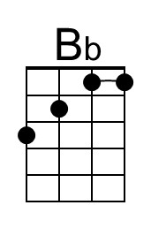 |  | 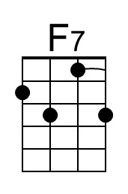 |  | 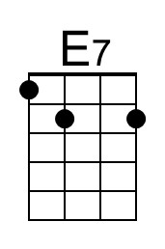 | 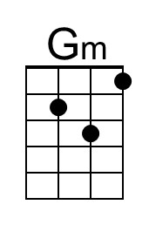
 | 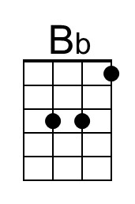 |  | 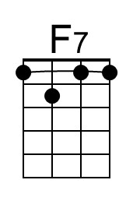 |  | 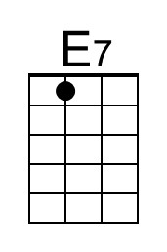 | 