**O Holy Night**

C33C

**Key C**

**C F C**

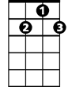

G7



C

F



O Ho ly Night, the stars are brightly shining

**G7 C**

It is the night of our dear Savior's birth

**F C**

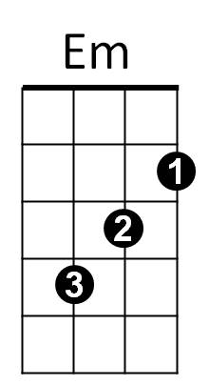Long lay the world in sin and error pining

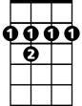

B7

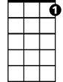

C7

**C7 Em B7 Em**

'Til He appeared and the soul felt its worth

**G7 C**

A thrill of hope the weary world rejoices

**G7 C**



G

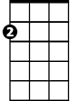

Am

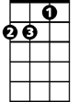

Dm

For yonder breaks a new and glorious morn.

**Am Em**

Fall on your knees,

**Dm Am**

O hear the angels voices.

**C G7 C F**

O ni-ght ~ divine,

**C G7 C**

**BARITONE**

O night - when Christ was born



F

C



G7

**G C Dm C G7 C**

O night di-vi-ne, O night, O night divine.

**Repeat entire song**



Em

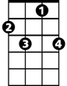

C7

B7

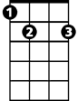

G

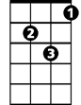

Dm



Am

**O Holy Night**

C 33F

**Key F**

**F Bb F**



C7



Bb

F



O Holy Night, the stars are brightly shining

**C7 F**

It is the night of our dear Savior's birth

**Bb F**

Long lay the world in sin an d error pining



Dm

E7



Am

**Am E7 Am**

'Til He appeared and the soul felt its worth

**C7 F**

A thrill of hope the weary world rejoices

**C7 F**

For yonder breaks a new and glorious morn.



C



Gm



F7

**Dm Am**

Fall on your knees,

**Gm Dm**

O hear the angels voices.

**F C7 F Bb**

O ni-ght ~ divine,

**F C7 F**

**BARITONE**

O night - when Christ was born



C7

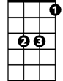

Bb



F

**C F Gm F C7 F**

O night di-vi-ne, O night, O night divine.

**Repeat entire song**

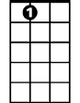

E7



Dm



Am

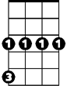

Gm

C

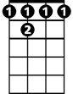

F 7