
O Little Town Of Bethlehem
C34 C
Lyrics by Phillips Brooks (1868); Tune of "St. Louis" by Lewis Redner (1868)

Intro Last 2 lines of verse  C Dm  O little town of Bethlehem,  C G7 C  How still we see thee lie!  A7 Dm  Above thy deep and dreamless sleep,  C G7 C  The silent stars go by.  Am Dm E7  Yet in thy dark streets shineth  Am E7  The everlasting Light,  C Dm  The hopes and fears of all the years,  C G7 C  Are met in thee tonight.  C Dm  O morning stars, together  C G7 C  Proclaim thy holy birth  A7 Dm  And praises sing to God, the King,  C G7 C  And peace to men on earth.  Am Dm E7  For Christ is born of Mary,  Am E7  And gathered all above,  C Dm  While mortals sleep, the angels keep  C G7 C  Their watch of wondering love. |  |  |  |  | C Dm  How silently, how silently,  C G7 C  The wondrous Gift is giv'n!  A7 Dm  So God imparts to human hearts  C G7 C  The blessings of His heaven.  Am Dm E7  No ear may hear His coming,  Am E7  But in this world of sin,  C Dm  Where meek souls will receive Him still,  C G7 C  The dear Christ enters in.  C Dm  Where children pure and happy,  C G7 C  Pray to the blessed child.  A7 Dm  Where mis-ery cries out to thee,  C G7 C  Son of the mother mild;  Am Dm E7  Where charity stand watching,  Am E7  And faith holds wide the door,  C Dm  The dark night wakes, the glory breaks,  C G7 C  And Christ-mas comes once more.
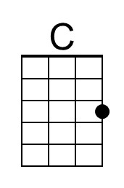 | 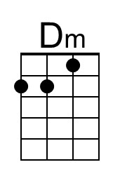 | 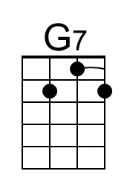 | 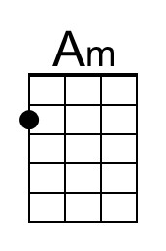 | 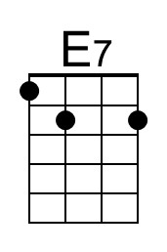 |  | 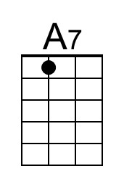
Baritone | 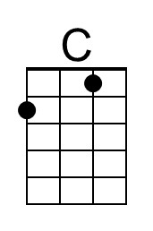 | 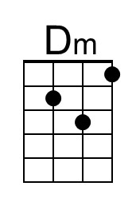 | 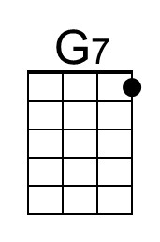 | 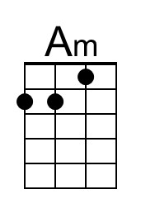 |  | 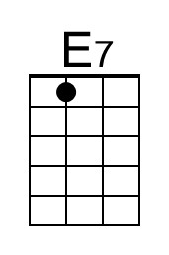 | 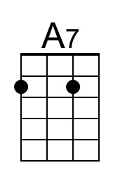

O Little Town Of Bethlehem
C34 G
Lyrics by Phillips Brooks (1868); Tune of "St. Louis" by Lewis Redner (1868)

Intro Last 2 lines of verse  G Am  O little town of Bethlehem,  G D7 G  How still we see thee lie!  E7 Am  Above thy deep and dreamless sleep,  G D7 G  The silent stars go by.  Em Am B7  Yet in thy dark streets shineth  Em B7  The everlasting Light,  G Am  The hopes and fears of all the years,  G D7 G  Are met in thee tonight.  G Am  O morning stars, together  G D7 G  Proclaim thy holy birth  E7 Am  And praises sing to God, the King,  G D7 G  And peace to men on earth.  Em Am B7  For Christ is born of Mary,  Em B7  And gathered all above,  G Am  While mortals sleep, the angels keep  G D7 G  Their watch of wondering love. |  |  |  |  | G Am  How silently, how silently,  G D7 G  The wondrous Gift is giv'n!  E7 Am  So God imparts to human hearts  G D7 G  The blessings of His heaven.  Em Am B7  No ear may hear His coming,  Em B7  But in this world of sin,  G Am  Where meek souls will receive Him still,  G D7 G  The dear Christ enters in.  G Am  Where children pure and happy,  G D7 G  Pray to the blessed child.  E7 Am  Where mis-ery cries out to thee,  G D7 G  Son of the mother mild;  Em Am B7  Where charity stand watching,  Em B7  And faith holds wide the door,  G Am  The dark night wakes, the glory breaks,  G D7 G  And Christ-mas comes once more.
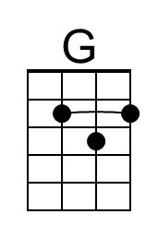 |  | 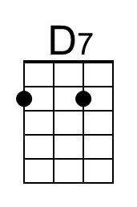 | 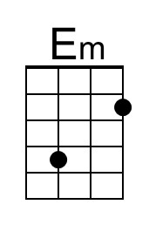 | 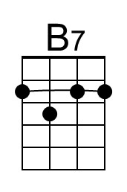
Baritone | 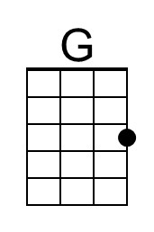 |  | 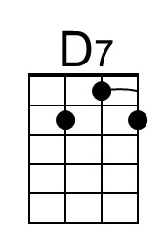 | 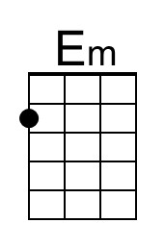 |  | 