**O Little Town Of Bethlehem**

C 34

**Intro: last 2 lines of verse**

**C Dm**

O little town of Bethlehem,

**C G7 C**

How still we see thee lie!

**A7 Dm**

Above thy deep and dreamless sleep,

**C G7 C**

The silent stars go by.

**Am Dm E7**

Yet in thy dark streets shineth

**Am E7**

The everlasting Light,

**C Dm**

The hopes and fears of all the years,

**C G7 C**

Are met in thee tonight.

**C Dm**

O morning stars, together

**C G7 C**

Proclaim thy holy birth

**A7 Dm**

And praises sing to God, the King,

**C G7 C**

And peace to men on earth.

**Am Dm E7**

For Christ is born of Mary,

**Am E7**

And gathered all above,

**C Dm**

While mortals sleep, the angels keep

**C G7 C**

Their watch of wondering love.

**C Dm**

How silently, how silently,

**C G7 C**

The wondrous Gift is giv'n!

**A7 Dm**

So God imparts to human hearts

**C G7 C**

The blessings of His heaven.

**Am Dm E7**

No ear may hear His coming,

**Am E7**

But in this world of sin,

**C Dm**

Where meek souls will receive Him still,

**C G7 C**

The dear Christ enters in.

**C Dm**

Where children pure and happy,

**C G7 C**

Pray to the blessed child.

**A7 Dm**

Where mis-ery cries out to thee,

**C G7 C**

Son of the mother mild;

**Am Dm E7**

Where charity stand watching,

**Am E7**

And faith holds wide the door,

**C Dm**

The dark night wakes, the glory breaks,

**C G7 C**

And Christ-mas comes once more.



C

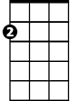

Am

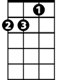

Dm

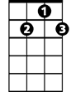

G7

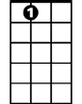

A7

E7

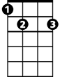

**BARITONE**

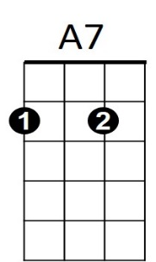



E7



Am

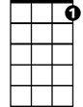

G7

C

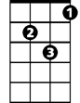

Dm